DAT601
Declan Dover

Assessment 1 Part 1.
Conceptual Database Design

1. Introduction to Data Modelling 4
1.1. Data Modelling in Information Systems 4
1.2. Relationships Between Conceptual, Logical, and Physical Stages 4
1.2.1. Conceptual 4
1.2.2. Logical 4
1.2.3. Physical 4
2. Description of Conceptual Modelling 5
2.1. Application of Extended Chen ERD 5
2.2. Entities 5
2.2.1. Strong Entities 5
2.2.2. Weak Entities 5
2.3. Attributes 6
2.3.1. Simple Attributes 6
2.3.2. Composite Attributes 6
2.3.3. Multi-Valued Attributes 6
2.3.4. Derived Attributes 7
2.4. Candidate Keys 7
2.5. Relationships 7
2.5.1. Cardinality 8
2.5.2. One-to-one 8
2.5.3. One-to-many 8
2.5.4. Many-to-many 8
2.5.5. Participation 9
2.5.6. Strong Relationships 9
2.5.7. Identifying Relationships 10
3. Conceptual ER Model 10
3.1. Conceptual ER Model 11
3.2. Rationale 12
3.2.1. Entities 12
3.2.2. Relationships 12
3.2.3. Other Design Decisions 14
4. Data Dictionary 15
4.1. Entities 15
4.2. Relationships 17
4.3. Attributes 18
4.4. Rationale 29
4.4.1. Entities 29
4.4.2. Relationships 29
4.4.3. Attributes 29
5. Business Rules 30
5.1. Business Rules 30
5.1.1. Business Rules 30
5.1.2. Assumptions 31
5.1.3. Justification 31
6. Conclusion 31
7. Transformation from Conceptual to Logical 34
7.1. Introduction 34
7.2. Mapping Rules Strategy 34
8. The Logical Database Model 36
8.1. Presentation 36
8.2. Explanation of Relations 38
9. Normalisation 39
9.1. Definitions 39
9.2. The Process 40
9.2.1. First Normal Form (1NF) 40
9.2.2. Second Normal Form (2NF) 40
9.2.3. Third Normal Form (3NF) 41
9.3. Advanced Normalisation 41
10. Logical Data Dictionary 42
10.1. Relations 42
10.2. Attributes 43
11. NaLER Analysis 58
11.1. The Method 58
11.2. The Analysis 58
11.2.1. Attribute Sentences 58
11.2.2. Relationship Sentences 60
11.3. Conclusion 62
12. Physical Database Design & Sizing 64
12.1. Logical to Physical Transformation 64
12.1.1. Base Relations 65
12.1.2. Constraints 66
12.2. Transaction Analysis 66
12.2.1. Transaction Diagrams 67
12.2.1.1. - D 67
12.2.1.2. - J 67
12.2.2. Transaction A 68
12.2.3. Transaction B 68
12.2.4. Transaction C 69
12.2.5. Transaction D 69
12.2.6. Transaction E 70
12.2.7. Transaction F 70
12.2.8. Transaction G 71
12.2.9. Transaction H 71
12.2.10. Transaction I 71
12.2.11. Transaction J 72
12.3. File Organisation 72
12.4. Secondary Indexes 72
12.5. Database Sizing 73
13. Database Build (DDL) & Test Data (DML) 75
13.1. The Build (DDL) 75
13.2. Test Data Generation (DML) 75
14. Transaction Implementation (Stored Procedures) 76
14.1. Transaction Queries 76
14.1.1. Transaction A 76
14.1.2. Transaction B 76
14.1.3. Transaction C 76
14.1.4. Transaction D 76
14.1.5. Transaction E 77
14.1.6. Transaction F 77
14.1.7. Transaction G 77
14.1.8. Transaction H 78
14.1.9. Transaction I 78
14.1.10. Transaction J 78
15. Security Mechanisms 79
15.1. User roles 79
15.2. Access Rules 79
15.2.1. Director 79
15.2.2. Administrative Executive 79
15.2.3. Salesperson 79
15.2.4. Technical Engineer 80
15.2.5. Third Party Maintainer 80
16. Final Reflection - Principles of Data Management 80
16.1. Tabulated Reflection 80
16.2. Complete the Lifecycle 82
16.2.1. Principle of Accountability 82
16.2.2. Principle of Transparency 82
16.2.3. Principle of Integrity 82
16.2.4. Principle of Protection 82
16.2.5. Principle of Compliance 82
16.2.6. Principle of Availability 83
16.2.7. Principle of Retention 83
16.2.8. Principle of Disposition 83
17. References 83

1. Introduction to Data Modelling

1.1. Data Modelling in Information Systems

Data modelling is the creation of visual representations of the data in a system. It is used to illustrate the types of data within a system, the relationships between the data, the different ways in which it can be grouped and organised, and the different attributes belonging to each type of data (What Is Data Modeling?, 2021). The use of this modelling helps us to understand database structure and design, which enables proper management of the data and enables organisations to turn that data into usable knowledge and information.

1.2. Relationships Between Conceptual, Logical, and Physical Stages

Conceptual, logical, and physical diagrams are three different ways of modelling data. Each model focuses on a different audience and a different perspective on the data within a system (Conceptual, Logical and Physical Data Model, n.d.). In a typical design process the modelling would take in place in the order:

Conceptual → Logical → Physical

1.2.1. Conceptual

The conceptual model is a high level visualisation of the database that is independent of physical considerations. It is used to find out what data exists within a system rather than how the data will be stored.

1.2.2. Logical

The logical model is a more structured form of the data from the conceptual model, converting entities into tables, attributes into columns, and starting to describe relationships using primary and foreign keys. Normalisation is usually applied at this stage.

1.2.3. Physical

The physical model takes the logical model and applies it to specific hardware or a DBMS. Things like performance and security that are not part of the logical model are considered at the physical stage.

2. Description of Conceptual Modelling

2.1. Application of Extended Chen ERD

Extended CHEN notation is a conceptual model used for modelling the data requirements of a system. This model allows for real world entities and systems to be visualised in a way that can be used as a basis for a future logical model. The different parts of CHEN notation are as follows:

2.2. Entities

An entity represents an object or concept that a system needs to store data about. Each entity needs to be uniquely identifiable meaning no 2 entities can be identical in all their attributes (Athuraliya, 2025). The extended Chen ERD we will be using for this project has 2 types of entities:

2.2.1. Strong Entities

A strong entity is an entity that can exist on its own, and does not rely on another entity to identify it. A strong entity is depicted by a solid rectangle containing its name.

Depiction:

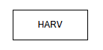

2.2.2. Weak Entities

A weak entity is an entity that is dependent on a related strong entity for part of its identity. A weak entity can’t exist without its related strong entity. A weak entity is depicted by a double rectangle containing its name.

Depiction:

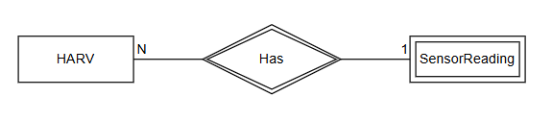

2.3. Attributes

Attributes describe the properties or characteristics of an entity or relationship. They help to define the details about entities or relationships and to distinguish between instances. Extended Chen ERD has four types of attributes:

2.3.1. Simple Attributes

A simple attribute holds a single value. It is depicted by a solid oval containing the name of the attribute.

Depiction:

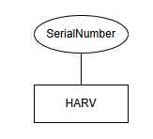

2.3.2. Composite Attributes

A composite attribute is an attribute that has its own sub-attributes. It is depicted as an oval with other ovals connected to it, containing the names of the sub-attributes.

Depiction:

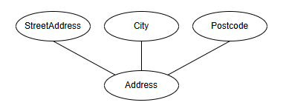

2.3.3. Multi-Valued Attributes

A multi-valued attribute is an attribute that can hold more than one value for a single entity. It is depicted by a double oval containing the attributes name.

Depiction:

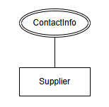

2.3.4. Derived Attributes

A derived attribute is an attribute that’s value can be calculated using other data within the system. It is depicted as a dashed oval containing the attributes name.

Depiction:

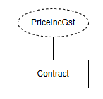

2.4. Candidate Keys

A candidate key is an attribute or set of attributes that can be used to uniquely identify an instance of an entity. A candidate key is depicted by underlining the name of an attribute, or multiple attributes, connected to an entity.

Depiction:

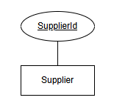

2.5. Relationships

A relationship represents an association between entities in a database. Relationships are described by the verbs that link entities. Relationships are depicted with lines connecting them to the entities. These connecting lines can also depict properties of the relationship. These properties are:

2.5.1. Cardinality

The cardinality of a relationship defines the number of each relationship that an entity instance can have. Three types of cardinality can be represented:

2.5.2. One-to-one

A one-to-one relationship is where each instance of an entity can only have one relationship of that type. It is depicted with a 1 at the beginning of the line joining an entity to a relationship.

Depiction:

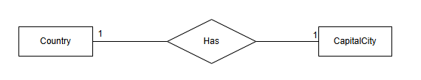

2.5.3. One-to-many

A one-to-many relationship is where the first entity instance can have relationships with many instances of the second entity, but an instance of the second entity can have only one relationship with an instance of the first entity. It is depicted with a 1 by the entity that can have many relationships and a N beside the entity that can have only one of that relationship.

Depiction:

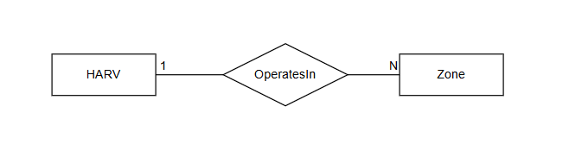

2.5.4. Many-to-many

A many-to-many relationship is where an instance of each entity in that relationship can have many of those relationships. It is depicted with an M beside one entity and an N beside the other.

Depiction:

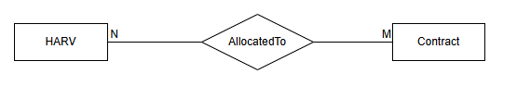

2.5.5. Participation

Participation in a relationship defines whether the relationship is mandatory or optional for an entity. Total participation, meaning that each instance of an entity must participate in that relationship, is represented by a double line. Partial participation, meaning each instance of an entity may or may not participate in that relationship, is depicted with a single line.

Depiction:

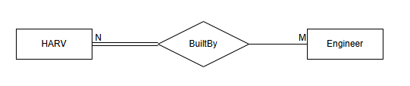

2.5.6. Strong Relationships

A strong relationship is a relationship between entities that can exist independently from other entities. Strong relationships are depicted by a solid diamond containing a description of the relationship.

Depiction:



2.5.7. Identifying Relationships

An identifying relationship is a relationship between a strong entity and one of its associated weak entities, described above. This is the relationship which the weak entity is dependent on for part of its identity. It is depicted by a double diamond containing a description of the relationship.

Depiction:

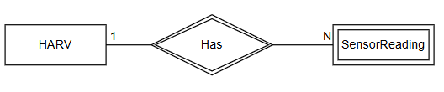

3. Conceptual ER Model

3.1. Conceptual ER Model
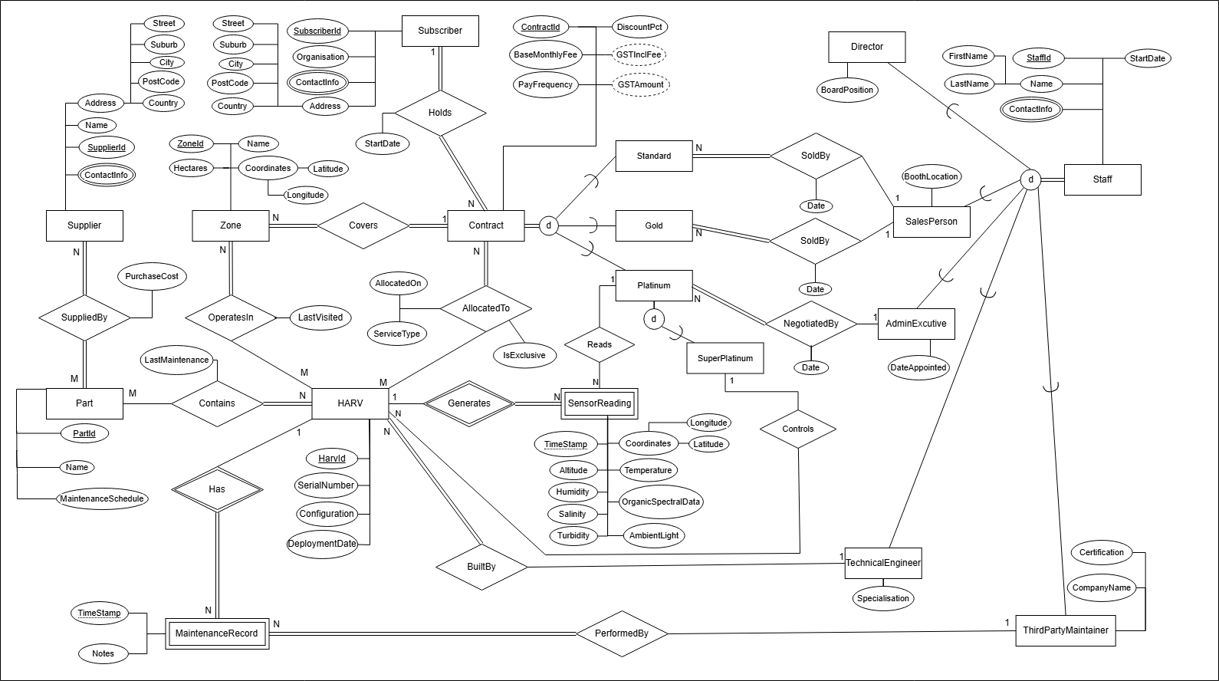

3.2. Rationale

3.2.1. Entities

HARV, Subscriber, Contract, Zone, Staff, Part, and Supplier are all strong entities within my model because they can exist independently of any other entity in the system, however, there are two weak entities in the model, SensorReading, which cannot exist without the HARV that collected the reading, and MaintenanceRecord, which cannot exist without the HARV for which this is a record of maintenance upon.

The staff entity exists in my model as a supertype with total disjoint separation into 5 subtypes, which are the 5 roles described in the project brief. This is because my model makes the assumption that all staff must be one of these set roles, and they cannot hold multiple of these roles.

The contract entity also exists as a supertype within my model. Each contract must be either a standard, gold, or platinum subscription. Each of these subtypes has their own relationships. The platinum subtype is also a supertype, and a partial disjoint relationship connects it to the ‘SuperPlatinum’ Entity. This partial disjoint means a platinum subscription can be a superplatinum subscription but does not have to be. This is because the project brief states that a super platinum subscription is a type of platinum subscription.

All the entities within the model have the relevant attributes needed to describe them and hold relevant information for the company. Each entity has an attribute or combination of attributes that can be used to uniquely identify them. Weak entities have an attribute that can be used in combination with the identifier of the strong entity to uniquely identify them. These are the timestamp attributes on SensorReading and MaintenanceRecord, which in combination with the HarvId of the HARV entity they are dependent on can be used to uniquely identify them.

3.2.2. Relationships

The ‘Holds’ relationship between Subscriber and Contract in model is a 1 to many relationship, with total participation on both sides, as a subscriber can hold many relationships, and must hold at least one to have a purpose within the system, while a contract must be held by exactly 1 subscriber. The same is true for the ‘Covers’ relationship between Contract and Zone, as a Contract must cover at least 1 zone, and a zone must be covered by only one contract for it to have a reason to exist within the system.

The BuiltBy relationship between HARV and TechnicalEngineer is a many to 1 relationship, with total participation on the side of the HARV. This is because all HARVs were built by a technical engineer, but a technical engineer may have built more than one HARV, or may not have built any HARVs yet. The performedBy relationship between MaintenanceRecord and ThirdPartyMaintainer follows the same structure, as a maintenance record must have a single third party maintainer it was performed by, but a third party maintainer could have performed none or multiple maintenance records.

My model contains two identifying relationships, both owned by the HARV entity. These relationships are for the two weak entities in the model, SensorReading and MaintenanceRecord. This is because these weak entities cannot exist without a relationship to their HARV.

My model contains four many-to-many relationships. The first is SuppliedBy which is between Supplier and Part. This relationship has total participation on both sides because a supplier must supply at least one part to have a reason to exist within the system, and a part must have a supplier that supplies it. It is a many to many because a part could be supplied by multiple suppliers and a supplier can supply multiple different parts. The second many-to-many relationship is Contains, which is between Part and HARV, with total participation on the side of the HARV. This is because multiple HARVS can use the same parts, and a HARV must contain at least one part in order to exist. The third and fourth many-to-many relationships are OperatesIn, which is between HARV and Zone, and AllocatedTo, between HARV and Contract. These relationships are many to many because a contract or zone can have many HARVs assigned to them, and a HARV can be assigned to many contracts or zones. Both of these relationships have total participation on the side of Contract and Zone because a Zone or Contract with no HARVs assigned to them have no reason to exist within the system.

As well as the BuiltBy relationship described earlier, my model also contains three other one-to-many, total to partial relationships. The first two of these are between the salesperson entity and the standard and gold subscription subtypes of the contract entity.. The next one-to-many is between AdminExecutive and a platinum subtype of the Contract entity. This relationship is based on the same assumption as the previous relationships as it is stated in the project brief that platinum subscriptions are negotiated not by salespeople but by admin executive staff. All of these three relationships have total participation on the side of the contract subtype, as for a contract to be created it must have been sold or negotiated by an employee, and partial participation on the respective employee’s side, as these salespeople or admin executive may have yet to negotiate or sell a contract.

The model also contains two one-to-many, partial to partial relationships. The first of these is the ‘Controls’ relationship between a superplatinum contract and a HARV. This relationship has partial participation on both sides as exclusive control of a HARV is an optional feature of the contract. This relationship also states that one HARV can only be exclusively controlled by a single contract, implied by the term exclusive. The second of these is the ‘Reads’ relationship between SuperPlatinum and SensorReading. This relationship assumes that a sensor reading can be read by only one subscription, but can also be read by no subscriptions, and that a subscription could read many sensor readings but also none.

Some relationships have attributes that are used to further describe a specific relationship. These attributes are PurchaseCost, describing the cost of a part supplied by a supplier in the SuppliedBy relationship, LastMaintenance, describing the last time a part underwent maintenance that is part of the Contains relationship between HARV and Part, and LastVisited, describing the last time a HARV visited a zone as part of an OperatesIn relationship. All SoldBy relationships between a contract and a member of staff have a Date attribute that contains the date that contract was sold. The AllocatedTo relationship between HARV and contract has three attributes, IsExclusive which describes whether a HARV is exclusive to a contract, AllocatedOn which is the date a HARV was allocated to a contract, and ServiceType, which describes the service the HARV is allocated to perform.

3.2.3. Other Design Decisions

Partial participation is applied from the HARV side of the ‘OperatesIn’ relationship as a HARV can exist within the system and not be deployed to a zone. Total participation is applied from the Zone side as a zone must have at least one HARV operating within it or it has no reason to exist within the system.

Part is modelled as a part type rather than a specific physical instance of a part. The same part type may be installed across many HARVs, and each HARV contains many part types. The HARV–Part relationship tracks LastMaintenanceDate per HARV per part type.

The SensorReading entity uses only one attribute for its altitude and depth. This is because a negative altitude reading can be used as the HARVs depth reading.

4. Data Dictionary

4.1. Entities

Entity Name | Description | Aliases | Occurence
Subscriber | Represents a single instance of a customer that has subscribed to any contract type. | Customer, Client | When a new customer purchases a subscription.
Contract | Represents a single instance of a contract that a customer has subscribed to. | Subscription | When a new or existing customer makes a new subscription.
Standard | Represents a contract at the standard subscription level. | Standard Subscription, Standard Contract | When a new or existing customer purchases a standard subscription.
Gold | Represents a contract at the gold subscription level. | Gold Subscription,  Gold Contract | When a new or existing customer purchases a gold subscription.
Platinum | Represents a contract at the platinum subscription level. | Platinum Subscription,  Platinum Contract | When a new or existing customer purchases a platinum subscription.
SuperPlatinum | Represents a contract at the super platinum subscription level. | Super platinum Subscription,  Super platinum Contract | When a new or existing customer purchases a super platinum subscription.
Zone | Represents a zone that is included in a contract. | Operating Area | When a subscription is purchased any zones it will cover will be created as a zone instance.
HARV | Represents a single HARV drone. | Drone | When a HARV is built by a technical engineer a new HARV instance will be created.
Supplier | Represents a single supplier that supplies any HARV parts to the company. | Vendor | When a part is ordered from a supplier that does not already exist in the database a new supplier instance will be created.
Part | Represents a type of part that is included in one or more HARVs | Component | When a HARV is built any parts not already existing in the database will be added.
SensorReading | Represents a single sensor reading for a HARV at a specific point in time | Sensor data | A sensor reading is produced by HARVs that are assigned to a contract that gives subscribers access to HARV data
MaintenanceRecord | Represents the results of a maintenance task performed on a HARV | Maintenance Report | A third party maintainer will produce maintenance records when carrying out maintenance on a HARV
Staff | Represents a single company employee | Employee | Every company employee and third party contractor hired by the company will have a staff entry
Director | Represents a director of the company |  | A new or existing employee assigned the position of director
SalesPerson | Represents an employee with the role of sales person |  | A new or existing employee assigned the position of salesperson
AdminExecutive | Represents an employee with the role of administrative executive | Administrative Executive | A new or existing employee assigned the position of administrative executive
TechnicalEngineer | Represents an employee with the role of technical engineer | Engineer | A new or existing employee assigned the position of technical engineer
ThirdPartyMaintainer | Represents a third party engineer contracted to the company | Maintainer | A new or existing contractor hired to perform maintenance on HARVs

4.2. Relationships

Entity Name | Cardinality | Participation | Relationship | Participation | Cardinality | Entity Name
Subscriber | 1 | Total | Holds | Total | N | Contract
Zone | N | Total | Covers | Total | 1 | Contract
Contract | N | Total | AllocatedTo | Partial | M | HARV
HARV | M | Partial | OperatesIn | Total | N | Zone
HARV | N | Total | Contains | Partial | M | Part
HARV | 1 | Partial | Has | Total | N | MaintenanceRecord
HARV | N | Total | BuiltyBy | Partial | 1 | TechnicalEngineer
HARV | 1 | Partial | Generates | Total | N | SensorReading
Part | M | Total | SuppliedBy | Total | N | Supplier
Standard | N | Total | SoldBy | Partial | 1 | SalesPerson
Gold | N | Total | SoldBy | Partial | 1 | SalesPerson
Platinum | N | Total | NegotiatedBy | Partial | 1 | AdminExecutive
Platinum | 1 | Partial | Reads | Partial | N | SensorReading
SuperPlatinum | 1 | Partial | Controls | Partial | N | HARV
MaintenanceRecord | N | Total | PerformedBy | Partial | 1 | ThirdPartyMaintainer
Staff | Total |  | Specialisation | Disjoint |  | Director
 | Total |  | Specialisation | Disjoint |  | SalesPerson
 | Total |  | Specialisation | Disjoint |  | AdminExecutive
 | Total |  | Specialisation | Disjoint |  | TechnicalEngineer
 | Total |  | Specialisation | Disjoint |  | ThirdPartyMaintainer
Contract | Total |  | Specialisation | Disjoint |  | Standard
 | Total |  | Specialisation | Disjoint |  | Gold
 | Total |  | Specialisation | Disjoint |  | Platinum
Platinum | Partial |  | Specialisation | Disjoint |  | SuperPlatinum

4.3. Attributes

Entity Name | Attributes | Description | Domain | Aliases | Composite | Derived | Nulls | Key? | Default Value
Subscriber | SubscriberId | Unique Identifying number for a subscriber | INTEGER, auto-incremented |  | No | No | No | PK
 | Organisation | The organisation that the subscriber represents | VARCHAR(255) | Company | No | No | No | No
 | ContactInfo | A multivalued attribute containing a name, phone number, and/or email address | VARCHAR(255) |  | No | No | Yes | No
 | Address | A composite attribute for the subscribers address values; Street, Suburb, City, PostCode, Country | Street:  VARCHAR(255)  Suburb:  VARCHAR(255)  City:  VARCHAR(255)  Postcode:  VARCHAR(255)  City:  VARCHAR(255) |  | Yes | No | Yes | No

Entity Name | Attributes | Description | Domain | Aliases | Composite | Derived | Nulls | Key? | Default Value
Contract | ContractId | Unique Identifying number for a contract | INTEGER, auto-incremented |  | No | No | No | PK
 | BaseMonthlyFee | The base monthly fee before discount of the contract | DECIMAL(10,2) |  | No | No | No | No
 | PayFrequency | The pay frequency for the contract, monthly or yearly | VARCHAR(10) |  | No | No | No | No
 | DiscountPct | The applied discount for the contract, between 0 and 3 and represents a % discount | DECIMAL(5,2), 0.00–3.00 Between 0 and 3, represents a % discount |  | No | No | No | No
 | GSTInclFee | The fee after discounts and GST are applied | DECIMAL(10,2) |  | No | Yes | No | No
 | GSTAmount | The total GST amount of the contract fee | DECIMAL(10,2) |  | No | Yes | No | No

Entity Name | Attributes | Description | Domain | Aliases | Composite | Derived | Nulls | Key? | Default Value
Zone | ZoneId | Unique Identifying number for a zone | INTEGER, auto-incremented |  | No | No | No | PK
 | Name | The name of the zone | VARCHAR(255) |  | No | No | Yes | No
 | Hectares | The size of the zone in hectares | DECIMAL(10,2), positive |  | No | No | No | No
 | Coordinates | Composite attribute made up of a latitude and longitude representing the location of the zone | Latitude:  DECIMAL(8,6)  Longitude:  DECIMAL(9,6) |  | Yes | No | No | No

Entity Name | Attributes | Description | Domain | Aliases | Composite | Derived | Nulls | Key? | Default Value
HARV | HarvId | Unique Identifying number for a HARV | INTEGER, auto-incremented |  | No | No | No | PK
 | SerialNumber | The serial number for a HARV | VARCHAR(100) |  | No | No | No | Candidate Key
 | Configuration | The configuration of the HARV | VARCHAR(50) |  | No | No | No | No
 | DeploymentDate | The date the HARV was first deployed | DATE |  | No | No | Yes | No

Entity Name | Attributes | Description | Domain | Aliases | Composite | Derived | Nulls | Key? | Default Value
Supplier | SupplierId | Unique Identifying number for a supplier | INTEGER, auto-incremented |  | No | No | No | PK
 | Address | A composite attribute for the supplier’s address values; Street, Suburb, City, PostCode, Country | Street:  VARCHAR(255)  Suburb:  VARCHAR(255)  City:  VARCHAR(255)  Postcode:  VARCHAR(255)  City:  VARCHAR(255) |  | Yes | No | No | No
 | Name | The name of the supplier | VARCHAR(255) |  | No | No | No | No
 | ContactInfo | A multivalued attribute containing a name, phone number, and/or email address | VARCHAR(255) |  | No | No | Yes | No

Entity Name | Attributes | Description | Domain | Aliases | Composite | Derived | Nulls | Key? | Default Value
Part | PartId | Unique Identifying number for a part | INTEGER, auto-incremented |  | No | No | No | PK
 | Name | The name of the part | VARCHAR(255) |  | No | No | No | No
 | MaintenanceSchedule | The amount of years between scheduled maintenance for the part | INTEGER |  | No | No | No | No

Entity Name | Attributes | Description | Domain | Aliases | Composite | Derived | Nulls | Key? | Default Value
SensorReading | TimeStamp | The date and time that the sensor reading was taken | DATETIME |  | No | No | No | PK with HarvId
 | Coordinates | Composite attribute made up of a latitude and longitude representing the location the reading was taken | Latitude:  DECIMAL(8,6)  Longitude:  DECIMAL(9,6) | Location | Yes | No | No | No
 | Altitude | The altitude the reading was taken at, a negative value represents a depth | DECIMAL(10,2) | Depth | No | No | No | No
 | Temperature | The temperature recorded by the HARV | DECIMAL(5,2) |  | No | No | No | No
 | Humidity | A % value representing the humidity that the HARV recorded | DECIMAL(5,2) |  | No | No | Yes | No
 | OrganicSpectralData | information generated by analyzing organic compounds using spectroscopic techniques | VARCHAR(255) |  | No | No | Yes | No
 | Salinity | A % value representing the salinity that the HARV recorded | DECIMAL(5,2) |  | No | No | Yes | No
 | Turbidity | the measure of relative clarity or cloudiness of a liquid (Unit NTU) | DECIMAL(10,4) |  | No | No | Yes | No
 | AmbientLight | A measure of the surrounding illumination intensity (Unit lux) | DECIMAL(10,2) |  | No | No | Yes | No

Entity Name | Attributes | Description | Domain | Aliases | Composite | Derived | Nulls | Key? | Default Value
MaintenanceRecord | TimeStamp | The date and time that the maintenance was carried out | DATETIME |  | No | No | No | PK with HarvId
 | Notes | Any notes about the maintenance | VARCHAR(255) |  | No | No | Yes | No

Entity Name | Attributes | Description | Domain | Aliases | Composite | Derived | Nulls | Key? | Default Value
Staff | StaffId | Unique Identifying number for an employee | INTEGER, auto-incremented | Employee ID | No | No | No | PK
 | StartDate | The date the employee started at the company | DATE | Hire date | No | No | No | No
 | Name | Composite attribute of a first name and last name | FirstName:  VARCHAR(255)  LastName:  VARCHAR(255) | Full name | Yes | No | No | No
 | ContactInfo | A multivalued attribute containing a name, phone number, and/or email address | VARCHAR(255) | Contact details | No | No | Yes | No

Entity Name | Attributes | Description | Domain | Aliases | Composite | Derived | Nulls | Key? | Default Value
Director | BoardPosition | The position the director holds on the company's board | VARCHAR(100) |  | No | No | Yes | No

Entity Name | Attributes | Description | Domain | Aliases | Composite | Derived | Nulls | Key? | Default Value
Salesperson | BoothLocation | The location of the salespersons booth | VARCHAR(255) | Shop location | No | No | Yes | No

Entity Name | Attributes | Description | Domain | Aliases | Composite | Derived | Nulls | Key? | Default Value
AdminExecutive | DateAppointed | The date the employee was appointed as an admin executive for the company | DATE |  | No | No | No | No

Entity Name | Attributes | Description | Domain | Aliases | Composite | Derived | Nulls | Key? | Default Value
TechnicalEngineer | Specialisation | The specialisation of the technical engineer that further describes their role | VARCHAR(255) | role | No | No | Yes | No

Entity Name | Attributes | Description | Domain | Aliases | Composite | Derived | Nulls | Key? | Default Value
ThirdPartyMaintainer | Certification | The certification of the third party maintainer that further describes their role | VARCHAR(255) |  | No | No | Yes | No
 | CompanyName | The name of the company the contractor works for | VARCHAR(255) |  | No | No | Yes | No

Relationship Name | Attributes | Description | Domain | Aliases | Composite | Derived | Nulls | Key? | Default Value
Holds | StartDate | The date the subscriber began the contract | DATE |  | No | No | No | No

Relationship Name | Attributes | Description | Domain | Aliases | Composite | Derived | Nulls | Key? | Default Value
SoldBy | Date | The date the subscription was sold | DATE |  | No | No | No | No

Relationship Name | Attributes | Description | Domain | Aliases | Composite | Derived | Nulls | Key? | Default Value
Negotiated By | Date | The date the subscription was negotiated | DATE |  | No | No | No | No

Relationship Name | Attributes | Description | Domain | Aliases | Composite | Derived | Nulls | Key? | Default Value
AllocatedTo | AllocatedOn | The date the HARV was allocated to the contract | DATE |  | No | No | No | No
 | ServiceType | The type of service the HARV is allocated to perform | VARCHAR(255) |  | No | No | No | No
 | IsExclusive | Describes whether the HARV is exclusive to the contract | BOOLEAN |  | No | No | No | No

Relationship Name | Attributes | Description | Domain | Aliases | Composite | Derived | Nulls | Key? | Default Value
SuppliedBy | PurchaseCost | The cost of a part when supplied by a specific supplier | DECIMAL(10.2) | Price | No | No | No | No

Relationship Name | Attributes | Description | Domain | Aliases | Composite | Derived | Nulls | Key? | Default Value
Contains | LastMaintenance | The date of the last maintenance of a part within a HARV | DATE |  | No | No | No | No

Relationship Name | Attributes | Description | Domain | Aliases | Composite | Derived | Nulls | Key? | Default Value
OperatesIn | LastVisited | The date that a HARV last visited a zone that it operates within | DATE |  | No | No | No | No

4.4. Rationale

4.4.1. Entities

The listed entities contain all those necessary to represent relevant data for the information inside the project brief. The entities have a clear description of what they represent in the system and a clear description of an occurrence of each entity. The weak entities in the dictionary describe instances of entities dependent on another strong entity and the reasoning for the decisions.

4.4.2. Relationships

The relationships table documents each relationship that exists within my ERD with a clear description of their cardinality and participation. Justifications for these types of relationships can be found in a previous section.

4.4.3. Attributes

The domains listed in my tables were chosen to match the type and precision required for the values based on the description in the project brief. Composite attributes that exist were broken into sub-attributes in order to allow querying on individual components, while keeping these attributes in relevant and understandable groups.

The dictionary contains two derived attributes, GstInclFee, which is calculated using the standard NZ GST rate of 15% and applying it to the base monthly fee after any discounts have been applied, and GstAmount, which is calculated by separating the total GST amount from the GST inclusive fee into a distinct value.

Appropriate fields that can be NULL have been identified, these are values within the sensor reading that can be null because not all HARVs take all of the readings, multivalued contact information attributes where there is not both an email and phone number that exist, and some of the individual staff attributes for situations where some specific roles may exist that do not completely fit a description, such as a technical engineer that has not yet been assigned a specialty or a director that has not been assigned a specific position on the board.

5. Business Rules

5.1. Business Rules

5.1.1. Business Rules

- Each HARV must be linked to the one technical engineer that built it.

- A salesperson may discount a standard or gold subscription by up to a maximum of 3%.

- Annual subscriptions for the standard and gold levels receive a 10% discount.

- A standard subscription covers one HARV with a single service in a single zone that is at most ten hectares.

- A gold subscription covers exactly three HARVs, each with one service, and exactly three zones with a total size of no more than one hundred hectares.

- Platinum and super-platinum subscriptions must be negotiated by an administrative executive.

- Only super platinum subscription holders have exclusive control of their HARVs.

- Only platinum and super platinum contract holders can access the sensor data of their HARVs.

- Only director level staff can change base monthly and annual subscription fees.

- The default maintenance schedule for each part is five years.

- HARVs may be allocated to more than one contract if zones overlap.

- Each part can be supplied by more than one supplier, and each supplier can supply more than one part.

- The purchase cost of a part must be recorded.

- Subscribers can view HARV locations only when HARVs are working in zones covered by their subscriptions.

- Standard and gold level subscriptions are sold by salesperson level staff only.

- Each subscription is paid in advance either annually or monthly.

- Invoices must include the GST exclusive amount, GST inclusive amount, and GST amount.

5.1.2. Assumptions

- GST rates follow the standard 15% for New Zealand based purchases.

- Each staff member holds only one role.

- A subscriber must hold at least one contract in order to exist.

- A part entity represents a part type and not a single physical part.

- A HARVs cache stores only one month of data and is stored in the database once successfully transferred.

- A negative altitude attribute for a HARV represents depth below sea level.

- A sensor reading can be read by only one subscriber as the reading belongs to the zone it was collected in.

5.1.3. Justification

The listed business rules and assumptions are based on the structure and design of my conceptual model, and the information within the project brief. Each business rule is based off of an operational constraint within the Coast and Canopy business model. The rules for subscription tiers describe the constraints of cardinality and participation within my ERD, specifically AllocatedTo, OperatesIn, and Contains. The rules around staff constraints with contract negotiation such as which staff members can negotiate which types of contracts and the different discounts they can apply are also described in the business rules. The business rules and assumptions are necessary to remove any ambiguity that cannot be described in the ERD using extended chen notation because of its limitations.

The assumptions listed also describe the reasoning for design decisions within my ERD. The assumption that each staff member can hold only one role justifies the total disjoint of the staff specialisation. Without this assumption and overlapping specialisation could overcomplicate the model. The assumption that a part entity represents a part type rather than a specific instance of a part is also important to the design of my ERD, as it allows the many to many relationship between HARV and part and the tracking of each HARV parts last carried out maintenance for that part, avoiding the need for individual records for every physical HARV component that exists. The assumption that a negative altitude attribute represents depth also simplifies the model and reduces the amount of necessary attributes for a sensor reading.

6. Conclusion

The Extended Chen notation was used to design a conceptual ERD for the company Coast and Canopy Robotics. The model captures all entities, relationships, and attributes necessary for the business operations that are described in the project brief.

The key design decisions for the model include the staff supertype's total disjoint specialisation into five different employee roles, this can be used to later enforce role-based access at the data model level. Another design decision is the contract supertype and its hierarchy, which separates contracts into three different levels and includes the super platinum level as a partial disjoint for a platinum contract, as the project brief describes these as a type of platinum contract. Another key decision was the choice to model the part entity as a part type rather than a physical part instance. The decision to use two weak entities, SensorReading and MaintenanceRecord, is based on the assumption that these entities cannot exist independently of a HARV entity.

The model will support all of the business operations described in the project brief, HARV deployment and telemetry data, maintenance and supply chain tracking, staff role enforcement, and the differences between contracts and how they are sold and negotiated.

This model provides a foundation for the logical and physical design phases that will take place in future, where the entities will become tables, attributes will become their columns, and the relationships will be implemented through the use of primary and foreign keys.

Assessment 1 Part 2.
Logical database design

7. Transformation from Conceptual to Logical

7.1. Introduction

The conceptual model from part one presented a rich and complete enterprise data model with sophisticated notation to represent the system presented in the project brief. The model from part one aims to help designers understand and specify the desired components of the database and the relationships among them using extended chen notation.

The goal of part two is to map that conceptual model to a particular logical model, in this case a relational database model. This will be done through explicit mapping rules, normalisation, and the use of NaLER analysis to verify the logical model against the business requirements from the project brief using natural language sentences. A logical ERD will be created to provide a visualisation of the new relational database.

A logical data dictionary will also be used to further describe the data in the logical model, such as its size and data type, as well as the constraints that will be applied to ensure the defined business requirements are met. The data dictionary will also include further descriptions of each relation that cannot be inferred in the logical ERD.

7.2. Mapping Rules Strategy

- Each strong entity from the conceptual model becomes a relation, or ‘table’.

This ensures that each strong entity has its own independent existence without depending on another entity.

- Weak entities become a table that borrows the primary key from the strong entity of which they are dependent on.

This ensures that these weak entities cannot be uniquely identified on their own and preserves their dependency on the entity they are dependent on.

- Composite attributes become two or more attributes within a relation.

This ensures that each part of the composite attribute can be queried and stored independently of each other.

- Simple attributes remain the same and become attributes in the new table.

Simple attributes already hold a single atomic value, so they can become a column in the relation without any changes to the structure of the data..

- Multi valued attributes will become a new relation, containing the primary key of the entity which had that attribute, and the value of the attribute.

Storing multiple values in a single column violates the first normal form, the creation of a new relation for multi valued attributes preserves the dependency of the attribute on its relation while allowing storage of multiple values.

- Each entity's candidate key will become its unique identifier once it has been tested against a set of criteria to determine if it is a suitable primary key.

This ensures that each entity has a unique identifier to ensure that it can be identified without depending on another entity. The testing ensures that the primary key meets all requirements.

- The tables will each have the name of the entity from which they were created.

Using the entity name maintains traceability between the conceptual and logical models, making the design easier to understand and verify against the original ERD.

- For one-to-many relationships the primary key from the one side becomes a foreign key in the table on its many side.

This is the standard relational way to represent a one-to-many dependency. It helps to avoid data duplication while preserving the links between relations.

- For many-to-many relationships a joining table will be created that takes the primary key from the relation on each side as foreign keys.

Many-to-many relationships cannot be directly represented in a relational model. A joining table resolves these relationships into two one-to-many relationships to represent them and preserve the link between these entities.

- Attributes from many-to-many relationships will become an attribute in that relationship’s joining table.

A relational model does not allow relationships to have their own attributes, moving these attributes on to the joining tables that represent the relationships ensure that these attributes continue to describe a specific pairing of entities.

- Attributes from other relationships will become a new relation where the primary and foreign key links will be the same as an associative relation but will also hold those attributes that were previously linked to the specific relationship

Creating a new relation for attributes of one-to-many relationships keeps the link the attribute has to both participating entities while conforming to a relational model. The foreign keys in the new relation represent this link where moving these attributes into either participating entity would not create a clean functional dependency.

- Each supertype will become a relation that holds all the common attributes that belong to every subtype.

This avoids repeating columns across every subtype and keeps shared data in a single relation.

- Each subtype will become a relation that holds only attributes that are specific to that subtype, as well as the primary key from the relation of its supertype.

This ensures that subtypes can have their own attributes and relationships independent of their supertype, enforcing the business logic described in the project brief. This avoids large numbers of nullable columns that would result from combining all the subtypes into a single supertype relation.

8. The Logical Database Model

8.1. Presentation

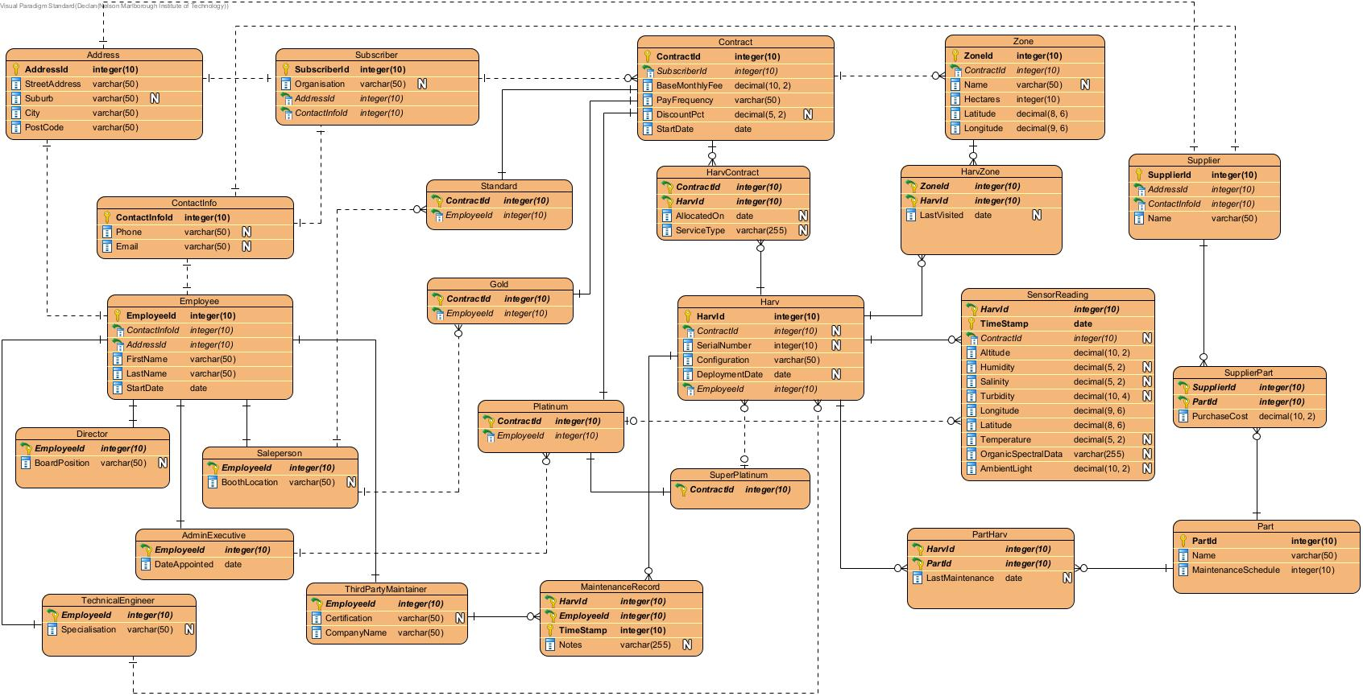

8.2. Explanation of Relations

The logical model contains 24 relations derived from the conceptual ERD. These are Address, ContactInfo, Subscriber, Contract, Zone, Harv, HarvZone, HarvContract, Employee, Director, Salesperson, AdminExecutive, TechnicalEngineer, ThirdPartyMaintainer, Standard, Gold, Platinum, SuperPlatinum, Supplier, Part, SupplierPart, PartHarv, SensorReading, and MaintenanceRecord.

Address stores all the address attributes which were part of a composite attribute in the conceptual model within the entities Subscriber, Employee, and Supplier. These attributes are now stored in the new Address relation with the primary key ‘AddressId’ that can be used by other relations as a foreign key to reference their address attributes. The ‘Suburb’ attribute may be null as mailing addresses do not require a suburb to be entered.

ContactInfo stores a phone number and email address attribute. This was a multi-valued attribute in the conceptual model associated with Subscriber, Employee, and Supplier. The new ContactInfo attribute stores these attributes as well as a primary key ‘ContactInfoId’, that can be used to reference a ContactInfo row as a foreign key in Subscriber, Employee, and Supplier.

Subscriber represents the clients who hold contracts with Coast and Canopy. The Organisation attribute is nullable as they could potentially be a private client not representing an organisation. This relations primary key is SubscriberId, referenced in the Contract relation as the contracts owner. Subscriber has the foreign keys of both Address and ContactInfo linking to their address and contact information.

Contract represents the contracts between Coast and Canopy and its subscribers. The subscriber that owns the contract is linked by the foreign key SubscriberId, representing that a subscriber could hold many contracts. Contract is uniquely identified by its primary key, the ContractId attribute, which is referenced as a foreign key in Zone, identifying which contract covers the zone, and HarvContract, representing a HARV being assigned to a contract. ContractId is a supertype with four subtypes, Standard, Gold, Platinum, and SuperPlatinum. Each subtype holds the ContractId as its primary key and foreign key to Contract. Standard, Gold, and Platinum each also hold an EmployeeId foreign key to Employee, representing the staff member responsible for managing that tier. SuperPlatinum holds no additional attributes beyond the inherited ContractId, distinguishing it purely by its relation to HARV that represents exclusive control of that HARV.

Zone represents the areas covered by a contract. Its name attribute is nullable as locations may be unnamed. It holds ContractId as a foreign key, indicating which specific contract covers that zone. Zone’s primary key, ZoneId, is referenced in HarvZone, link HARVs and the zones they operate in.

Harv represents the Hybrid Autonomous Resource Vehicles (HARV). Its EmployeeId foreign key links it to the technical engineer that built it. And its ContractId foreign key links it to the superplatinum contract which has exclusive control of it, this is a nullable attribute as not all HARVs are exclusively controlled.

Employee is a supertype that represents all of Coast and Canopies employees that are relevant to the operations within the project brief, named ‘Staff’ in the conceptual model. It has attributes that reference Address and ContactInfo, linking the employee to their address and contact information. This relation has five subtypes represented by their own relation, consisting of the EmployeeId taken from the employee as its primary and foreign key, and other attributes unique to that employee type. An employee within the database must be one of these employee subtypes.

Supplier represents vendors that supply different parts to Coast and Canopy. Its primary key is SupplierId, referenced in the joining table SupplierPart to indicate that a part is sold by a supplier. It also contains foreign keys referencing the suppliers address and contact information.

Part represents all the types of parts used within Coast and Canopies HARVs. Each row represents a part model, not a single instance of a part. Its primary key is PartId, referenced in SupplierPart to indicate that part has been purchased from a vendor, and in PartHarv, indicating that this type of part has been used to build a HARV.

The model contains four joining tables, used to represent many to many relationships between relations. These are HarvZone, HarvContract, SupplierPart, and PartHarv. These joining tables are used to represent many-to-many relationships. They take a foreign key from each of the relations participating in the relationship and they become the two parts of the joining table’s composite key. Using the keys in this way allows each side of the relationship to have multiple relationships with the other.

The two relations derived from weak entities are MaintenanceRecord and SensorReading. These take the primary key of the relation they are dependent on and use it as part of their composite key along with a timestamp. This is because a SensorReading is only uniquely identifiable in the context of the HARV that recorded it and a MaintenanceRecord is the same for the employee that made the record and the HARV that the record was made for. All sensor attributes are nullable to account for sensors that may not be active on every reading.

9. Normalisation

9.1. Definitions

1st normal form requires that the intersection of each row and column contains only a single value. It also requires that each relation has a column or multiple columns that serve as a unique identifier for that relation.

2nd normal form requires that a relation is in 1st normal form, it is fully functionally dependent on its primary key, and has no part-key dependencies.

3rd normal form requires that a relation is in both 1st and 2nd normal form, and has no transitive dependencies. This means that no non-primary-key attribute in the relation is transitively dependent on the primary key.

Boyce-Codd normal form requires that a relation is in 1st, 2nd, and 3rd normal form, and that the left side of each functional dependency, the determinant, is a candidate key.

4th normal form requires that a relation is in BCNF and contains no non-trivial multivalued dependencies. This means that no attribute should independently map multiple values to the same key unless those values are functionally dependent on each other.

9.2. The Process

9.2.1. First Normal Form (1NF)

In the conceptual model for the database there were three attributes that violated atomicity, the ‘Address’ composite attribute found within Subscriber and Supplier, the ‘ContactInfo’ multi-valued attribute found within Employee, Subscriber, and Supplier, and the ‘location’ composite attribute within SensorReading and Zone.

The Address attribute from these entities was moved to a new relation, with an AddressId column as its unique identifier and a column for each attribute that formed the composite address attribute in the entities. Each of those entities hold a foreign key for their address in the address relation.

The ContactInfo attribute was also moved to a new relation in the same way. This attribute was removed from those entities that had it and replaced with a ContactInfoId foreign key that references a row in the new relation.

The location composite attribute was removed from Zone and SensorReading and replaced with a Longitude and Latitude attribute within these relations.

All remaining attributes across each relation held single atomic values. Each relation has a defined primary key that serves as its unique identifier, ensuring that each relation is in first normal form.

9.2.2. Second Normal Form (2NF)

Second normal form was applied to any relations with a composite primary key. For each of these relations it was ensured that each non-key attribute is fully dependent on the entire composite key and contained no partial dependencies. The application of second normal form on these relations is as follows:

- HarvZone: The non-key attribute ‘LastVisted’ records the date and time a specific HARV visited a specific zone. It depends on the ID of both the zone and the HARV and therefore has no partial dependencies.

- HarvContract: The non-key attributes ‘AllocatedOn’ and ‘ServiceType’ describe the allocation of a specific HARV to a specific Contract. Both of these attributes depend on the full composite key and therefore there are no partial dependencies.

- SupplierPart: The non-key attribute ‘PurchaseCost’ is the cost of a specific part from a specific supplier. It therefore depends on both ‘SupplierId’ and ‘PartId’ as the same part from a different supplier or a different part from the same supplier may have a different cost.

- PartHarv: The non-key attribute ‘LastMaintenance’ is the date when a specific part was last maintained within a specific HARV. It therefore depends on both ‘HarvId’ and ‘PartId’ and has no partial dependencies.

- SensorReading: All non-key attributes in SensorReading describe a reading taken by a specific HARV at a specific time. Each of them is dependent on both of the composite key attributes and therefore has no partial dependencies.

- MaintenanceRecord: The non-key attribute ‘Notes’ describe a specific maintenance event performed by a specific employee on a specific HARV at a specific time. All three key components are required. No partial dependency.

As there are no other relations with composite keys all relations are in second normal form.

9.2.3. Third Normal Form (3NF)

Third normal form was applied to all relations. For each relation it was ensured that each non-key attribute is not dependent on another non-key attribute within that relation.

The ‘Contract’ relation contained two derived attributes that were dependent on other non-key attributes. The attribute ‘GstInclFee’ was dependent on the ‘BaseMonthlyFee’ attribute. I removed this attribute as it is derived and did not actually need to be stored in the relation. The ‘GstAmount’ attribute was dependent on the removed ‘GstInclFee’ attribute and was removed for the same reason.

Each other table is in third normal form because no transitive dependencies exist among the relations and therefore no non-key attributes are dependent on other non-key attributes.

9.3. Advanced Normalisation

Boyce-Codd normal form was applied to each relation within the logical model. Each relation was checked to ensure that every functional dependency is a candidate key.

In this model the only candidate key beyond the declared primary key is ‘SerialNumber’ in ‘Harv’, which can uniquely identify a HARV independently of HarvId. Since ‘SerialNumber’ is a candidate key it does not violate BCNF. No other non-key attribute in any of the relations acts as a determinant for another attribute therefore all relations satisfy BCNF.

Fourth normal form was applied to ensure that no relation contains non-trivial multivalued dependencies. As there are no relations in the schema where one key independently drives two unrelated sets of values, the relations all conform to the fourth normal form.

10. Logical Data Dictionary

10.1. Relations

Relation Name | Start Volume No. of rows loaded at the beginning | Growth e.g. no growth / 10% per year | Comments
Address | 5100 | 10% per year | One record per subscriber, employee, and supplier
Subscriber | 5000 | 10% per year | Estimated from contract volumes and subscription percentages in the brief
Zone | 35,000 | 15% per year | Brief states 30,000+ zones worldwide
ContactInfo | 5100 | 10% per year | One record per subscriber, employee, and supplier
SensorReading | 19,400,000,000 | 5% per year | Each HARV records one reading per second. Start volume based on 7,500 HARVs over 30 days.
HarvContract | 10,000 | 10% per year | HARVs can be allocated to multiple contracts. Estimated amount from HARV numbers.
HarvZone | 50,000 | 15% per year | At least one HARV per zone
Supplier | 25 | 5% per year | New suppliers added infrequently
Employee | 500 | 5% per year | Internal staff and contracted maintainers.
Director | 10 | No growth | Set amount of board positions
Salesperson | 300 | 5% per year | Largest employee group based off of Standard/Gold sales numbers
AdminExecutive | 50 | 3% per year | Senior management, grows slowly
TechnicalEngineer | 80 | 5% per year | Grows with demand for more HARVs
ThirdPartyMaintainer | 60 | 8% per year | Grows with HARV numbers
Contract | 7700 | 12% per year | Estimated from zone and HARV numbers
Standard | 7000 | 12% per year | Most common subscription
Gold | 667 | 10% per year | Brief states 1% of subscribers are Gold
Platinum | 20 | 5% per year | Brief states 0.5% of subscribers are Platinum
SuperPlatinum | 10 | 1 new contract per year | Brief explicitly states 10 Super Platinum contracts
Harv | 7500 | 5% per year | Brief states 7,500 HARVs deployed
SupplierPart | 250 | 5% per year | Grows as new parts and suppliers are added
Part | 150 | 3% per year | New types rarely added
PartHarv | 150000 | 5% per year | Grows with HARV numbers
MaintenanceRecord | 50000 | 10% per year | Grows continuously as maintenance events are logged across the fleet

10.2. Attributes

Relation Name | Attribute | Description | Data type | Length | Value range | Validation Rules | Default Value | Nulls | Key? | References Entity | Integrity Constraints
Address | AddressId | Unique identifier for address record | INT(10) | 8 | 0 - 99999999 | Unique, Auto increment | Auto | No | PK | - | Not Null, Unique
 | StreetAddress | Street number and name | VARCHAR(50) | 50 | - | - | - | No | FK | - | Not Null
 | Suburb | Suburb name | VARCHAR(50) | 50 | - | - | - | Yes | - | - | -
 | City | City name | VARCHAR(50) | 50 | - | - | - | No |  | - | Not Null
 | PostCode | Post code | VARCHAR(50) | 4 | - | - | - | No |  | - | Not Null

Relation Name | Attribute | Description | Data type | Length | Value range | Validation Rules | Default Value | Nulls | Key? | References Entity | Integrity Constraints
ContactInfo | ContactInfoId | Unique identifier for contact information record | INT(10) | 8 | 0 - 99999999 | Unique, Auto increment | Auto | No | PK | - | Not Null, Unique
 | Phone | Phone number | VARCHAR(50) | 50 | - | - | - | Yes | - | - | -
 | Email | Email address | VARCHAR(50) | 50 | - | - | - | Yes | - | - | -

Relation Name | Attribute | Description | Data type | Length | Value range | Validation Rules | Default Value | Nulls | Key? | References Entity | Integrity Constraints
Subscriber | SubscriberId | Unique identifier for subscriber record | INT(10) | 8 | 0 - 99999999 | Unique, Auto increment | Auto | No | PK | - | Not Null, Unique
 | Organisation | Name of the organisation the subscriber represents | VARCHAR(50) | 50 | - | - | - | Yes | - | - | -
 | AddressId | Key of the subscribers address in the address table | INT(10) | 8 | 0 - 99999999 | - | - | No | FK | Address | Not Null
 | ContactInfoId | Key of the subscribers contact information in the ContactInfo table | INT(10) | 8 | 0 - 99999999 | - | - | No | FK | ContactInfo | Not Null

Relation Name | Attribute | Description | Data type | Length | Value range | Validation Rules | Default Value | Nulls | Key? | References Entity | Integrity Constraints
Zone | ZoneId | Unique identifier for zone record | INT(10) | 8 | 0 - 99999999 | Unique, Auto increment | Auto | No | PK | - | Not Null, Unique
 | ContractId | Key of the contract which covers the zone | INT(10) | 8 | 0 - 99999999 | - | - | No | FK | Contract | Not Null
 | Name | Name (if any) of the zone | VARCHAR(50) | 50 | - | - | - | Yes | - | - | -
 | Hectares | The size of the zone in hectares | INT(10) | 4 | 0 - 1000 | - | - | No | - | - | -
 | Latitude | The latitude of the zone | DECIMAL(8, 6) | 14 | -90 - 90 | - | - | No | - | - | -
 | Longitude | The longitude of the zone | DECIMAL(9,6) | 15 | -180 - 180 | - | - | No | - | - | -

Relation Name | Attribute | Description | Data type | Length | Value range | Validation Rules | Default Value | Nulls | Key? | References Entity | Integrity Constraints
SensorReading | HarvId | HARV that made the reading | INT(10) | 8 | 0 - 99999999 | - | - | No | PK, FK | Harv | Not Null
 | TimeStamp | Date and time the reading was made | DATE | 23 | - | - | Current Date and Time | No | PK | - | -
 | ContractId | ID of the platinum contract which can view the reading (if any) | INT(10) | 8 | 0 - 99999999 | - | - | Yes | FK | Platinum | -
 | Latitude | The latitude of the reading | DECIMAL(8, 6) | 14 | -90 - 90 | - | - | No | - | - | -
 | Longitude | The longitude of the reading | DECIMAL(9,6) | 15 | -180 - 180 | - | - | No | - | - | -
 | Altitude | The altitude of the reading | DECIMAL(10, 2) | 12 | - | - | - | No | - | - | -
 | Humidity | The humidity sensed by the reading | DECIMAL(5, 2) | 7 | 1 -100 | - | - | Yes | - | - | Positive number
 | Salinity | The salinity sensed by the reading | DECIMAL(5, 2) | 7 | 1 -100 | - | - | Yes | - | - | Positive number
 | Turbidity | The turbidity sensed by the reading | DECIMAL(10, 4) | 14 | 1 -100 | - | - | Yes | - | - | Positive number
 | Temperature | The temperature sensed by the reading | DECIMAL(5, 2) | 7 | - | - | - | Yes | - | - | -
 | OrganicSpectralData | The information generated by interacting electromagnetic radiation with organic compounds | VARCHAR(255) | 255 | - | - | - | Yes | - | - | -
 | AmbientLight | The ambient light sensed by the reading | DECIMAL(10, 2) | 12 | 1 -1000 | - | - | Yes | - | - | Positive number

Relation Name | Attribute | Description | Data type | Length | Value range | Validation Rules | Default Value | Nulls | Key? | References Entity | Integrity Constraints
HarvContract | HarvId | HARV assigned to a contract | INT(10) | 8 | 0 - 99999999 | - | - | No | PK, FK | Harv | Not Null
 | ContractId | Contract with HARV assigned to it | INT(10) | 8 | 0 - 99999999 | - | - | No | PK, FK | Contract | Not Null
 | AllocatedOn | Date the HARV was allocated to the contract | DATE | 23 | - | - | - | Yes | - | - | -
 | ServiceType | Service the HARV is allocated to provide | VARCHAR(255) | - | - | - | - | Yes | - | - | -

Relation Name | Attribute | Description | Data type | Length | Value range | Validation Rules | Default Value | Nulls | Key? | References Entity | Integrity Constraints
HarvZone | HarvId | HARV assigned to a zone | INT(10) | 8 | 0 - 99999999 | - | - | No | PK, FK | Harv | Not Null
 | ZoneId | zone with HARV assigned to it | INT(10) | 8 | 0 - 99999999 | - | - | No | PK, FK | Zone | Not Null
 | AllocatedOn | Date the zone was last visited by the assigned HARV | DATE | 23 | - | - | - | Yes | - | - | -

Relation Name | Attribute | Description | Data type | Length | Value range | Validation Rules | Default Value | Nulls | Key? | References Entity | Integrity Constraints
Supplier | SupplierId | Unique identifier for supplier record | INT(10) | 8 | 0 - 99999999 | Unique, Auto increment | Auto | No | PK | - | Not Null, Unique
 | AddressId | Key of the subscribers address in the address table | INT(10) | 8 | 0 - 99999999 | - | - | No | FK | Address | Not Null
 | ContactInfoId | Key of the subscribers contact information in the ContactInfo table | INT(10) | 8 | 0 - 99999999 | - | - | No | FK | ContactInfo | Not Null
 | Name | Suppliers company name | VARCHAR(50) | 50 | - | - | - | No | - | - | -

Relation Name | Attribute | Description | Data type | Length | Value range | Validation Rules | Default Value | Nulls | Key? | References Entity | Integrity Constraints
Employee | EmployeeId | Unique identifier for employee record | INT(10) | 8 | 0 - 99999999 | Unique, Auto increment | Auto | No | PK | - | Not Null, Unique
 | AddressId | Key of the employees address in the address table | INT(10) | 8 | 0 - 99999999 | - | - | No | FK | Address | Not Null
 | ContactInfoId | Key of the employees contact information in the ContactInfo table | INT(10) | 8 | 0 - 99999999 | - | - | No | FK | ContactInfo | Not Null
 | FirstName | Employees first name | VARCHAR(50) | 50 | - | - | - | No | - | - | -
 | LastName | Employees last name | VARCHAR(50) | 50 | - | - | - | No | - | - | -
 | StartDate | Date employee started working for the company | DATE | 23 | - | - | - | No | - | - | -

Relation Name | Attribute | Description | Data type | Length | Value range | Validation Rules | Default Value | Nulls | Key? | References Entity | Integrity Constraints
Director | EmployeeId | The employees ID from the employee table | INT(10) | 8 | 0 - 99999999 | - | - | No | PK, FK | Employee | Not Null
 | BoardPosition | The position the director holds on the company’s board | VARCHAR(50) | 50 | - | - | - | Yes | - | - | -

Relation Name | Attribute | Description | Data type | Length | Value range | Validation Rules | Default Value | Nulls | Key? | References Entity | Integrity Constraints
Salesperson | EmployeeId | The employees ID from the employee table | INT(10) | 8 | 0 - 99999999 | - | - | No | PK, FK | Employee | Not Null
 | BoothLocation | The office or space where the Salesperson operates from | VARCHAR(50) | 50 | - | - | - | Yes | - | - | -

Relation Name | Attribute | Description | Data type | Length | Value range | Validation Rules | Default Value | Nulls | Key? | References Entity | Integrity Constraints
AdminExecutive | EmployeeId | The employees ID from the employee table | INT(10) | 8 | 0 - 99999999 | - | - | No | PK, FK | Employee | Not Null
 | DateAppointed | Date employee was promoted to Administrative Executive | DATE | 12 | - | - | - | No | – | - | Cannot be before the employees start date.

Relation Name | Attribute | Description | Data type | Length | Value range | Validation Rules | Default Value | Nulls | Key? | References Entity | Integrity Constraints
TechnicalEngineer | EmployeeId | The employees ID from the employee table | INT(10) | 8 | 0 - 99999999 | - | - | No | PK, FK | Employee | Not Null
 | Specialization | The engineers specializatiopn | VARCHAR(50) | 50 | - | - | - | Yes | - | - | -

Relation Name | Attribute | Description | Data type | Length | Value range | Validation Rules | Default Value | Nulls | Key? | References Entity | Integrity Constraints
ThirdPartyMaintainer | EmployeeId | The employees ID from the employee table | INT(10) | 8 | 0 - 99999999 | - | - | No | PK, FK | Employee | Not Null
 | Certification | The maintainers certification | VARCHAR(50) | 50 | - | - | - | Yes | - | - | -
 | CompanyName | The company the maintainer is contracted from | VARCHAR(50) | 50 | - | - | - | No | - | - | -

Relation Name | Attribute | Description | Data type | Length | Value range | Validation Rules | Default Value | Nulls | Key? | References Entity | Integrity Constraints
Contract | ContractId | Unique identifier for contract record | INT(10) | 8 | 0 - 99999999 | Unique, Auto increment | Auto | No | PK | - | Not Null, Unique
 | SubscriberId | ID of the subscriber that holds the contract | INT(10) | 8 | 0 - 99999999 | - | - | No | FK | Subscriber | Not Null
 | BaseMonthlyFee | Base monthly charge for the contract | DECIMAL(10, 2) | 12 | - | - | - | No | - | - | Must be positive
 | PayFrequency | Payment frequency | VARCHAR(50) | 50 | ‘Monthly’, ‘Yearly’ | Must be one of these defined values | ‘Monthly’ | No | - | - | Must be one of the set values
 | DiscountPct | The % discount applied | DECIMAL(5, 2) | 7 | 0 - 10 | 0-3 monthly, 10 yearly | - | Yes | - | - | Max discount 3 if monthly, 10% if yearly
 | StartDate | Date the contract was started or will be started | DATE | 12 | - | - | - | No | - | - | -

Relation Name | Attribute | Description | Data type | Length | Value range | Validation Rules | Default Value | Nulls | Key? | References Entity | Integrity Constraints
Standard | ContractId | Identifies the contract record in the main table that this subtype is linked to | INT(10) | 8 | 0 - 99999999 | Unique, Auto increment | Auto | No | PK, FK | Contract | Not Null, Unique
 | EmployeeId | The salesperson that negotiated this contract | INT(10) | 8 | 0 - 99999999 | - | - | No | FK | Salesperson | Not Null

Relation Name | Attribute | Description | Data type | Length | Value range | Validation Rules | Default Value | Nulls | Key? | References Entity | Integrity Constraints
Gold | ContractId | Identifies the contract record in the main table that this subtype is linked to | INT(10) | 8 | 0 - 99999999 | Unique, Auto increment | Auto | No | PK, FK | Contract | Not Null, Unique
 | EmployeeId | The salesperson that negotiated this contract | INT(10) | 8 | 0 - 99999999 | - | - | No | FK | Salesperson | Not Null,

Relation Name | Attribute | Description | Data type | Length | Value range | Validation Rules | Default Value | Nulls | Key? | References Entity | Integrity Constraints
Platinum | ContractId | Identifies the contract record in the main table that this subtype is linked to | INT(10) | 8 | 0 - 99999999 | Unique, Auto increment | Auto | No | PK, FK | Contract | Not Null, Unique
 | EmployeeId | The Administrative executive that negotiated this contract | INT(10) | 8 | 0 - 99999999 | - | - | No | FK | AdminExecutive | Not Null,

Relation Name | Attribute | Description | Data type | Length | Value range | Validation Rules | Default Value | Nulls | Key? | References Entity | Integrity Constraints
SuperPlatinum | ContractId | Identifies the contract record in the main table that this subtype is linked to | INT(10) | 8 | 0 - 99999999 | Unique, Auto increment | Auto | No | PK, FK | Contract | Not Null, Unique

Relation Name | Attribute | Description | Data type | Length | Value range | Validation Rules | Default Value | Nulls | Key? | References Entity | Integrity Constraints
Harv | HarvtId | Unique identifier for HARV record | INT(10) | 8 | 0 - 99999999 | Unique, Auto increment | Auto | No | PK | - | Not Null, Unique
 | ContractId | Superplatinum contract that has exclusive control (does not apply to every HARV) | INT(10) | 8 | 0 - 99999999 | - | - | Yes | FK | SuperPlatinum | Not Null, Unique
 | SerialNumber | HARVs serial number, used to reference HARV in company communication | INT(12) | 12 | - | - | - | Yes | - | - | -
 | Configuration | The current configuration of the HARV | VARCHAR(50) | 50 | - | - | - | No | - | - | -
 | DeploymentDate | The date the HARV was first deployed | DATE | 12 | - | - | - | Yes | - | - | -
 | EmployeeId | The ID of the Technical Engineer that built the HARV | INT(10) | 8 | 0 - 99999999 | - | - | No | FK | TechnicalEngineer | Not Null

Relation Name | Attribute | Description | Data type | Length | Value range | Validation Rules | Default Value | Nulls | Key? | References Entity | Integrity Constraints
SupplierPart | SupplierId | Supplier that sells the part | INT(10) | 8 | 0 - 99999999 | - | - | No | PK, FK | Supplier | Not Null
 | PartId | Part for sale | INT(10) | 8 | 0 - 99999999 | - | - | No | PK, FK | Part | Not Null
 | PurchaseCost | Cost of the part from the supplier | DECIMAL(10, 2) | 12 | - | - | - | No | - | - | Positive

Relation Name | Attribute | Description | Data type | Length | Value range | Validation Rules | Default Value | Nulls | Key? | References Entity | Integrity Constraints
PartHarv | PartId | Part used in a HARV | INT(10) | 8 | 0 - 99999999 | - | - | No | PK, FK | Part | Not Null
 | HarvId | HARV that contains a part | INT(10) | 8 | 0 - 99999999 | - | - | No | PK, FK | Harv | Not Null
 | LastMaintenance | Date of the parts last maintenance | DATE | 12 | - | - | - | Yes | - | - | -

Relation Name | Attribute | Description | Data type | Length | Value range | Validation Rules | Default Value | Nulls | Key? | References Entity | Integrity Constraints
MaintenanceRecord | HarvId | HARV that contains a part | INT(10) | 8 | 0 - 99999999 | - | - | No | PK, FK | Harv | Not Null
 | EmployeeId | The third party maintainer creating the record | INT(10) | 8 | 0 - 99999999 | - | - | No | FK | ThirdPartyMaintainer | Not Null
 | TimeStamp | The date and time of the maintenance | DATE | 12 | - | - | - | No | PK | - | Not Null
 | Notes | Any notes from the maintenance | VARCHAR(255) | 255 | - | - | - | Yes | - | - | -

11. NaLER Analysis

11.1. The Method

NaLER is a way to describe an entity relationship model in a way that is human readable. It can help to ensure that the model is readable by both the builder and the user. NaLER can be helpful to read back the database structure to humans in order to better understand it or check it against the information and business rules in the original description of the system.

11.2. The Analysis

11.2.1. Attribute Sentences

S1: Each Address is uniquely identified by one AddressId
S2: One Address (AddressId) must have one StreetAddress
S3: One Address (AddressId) may have one Suburb
S4: One Address (AddressId) must have one City
S5: One Address (AddressId) must have one PostCode

S6: Each ContactInfo is uniquely identified by one ContactInfoId
S7: One ContactInfo (ContactInfoId) may have one Phone
S8: One ContactInfo (ContactInfoId) may have one Email

S9: Each Subscriber is uniquely identified by one SubscriberId
S10: One Subscriber (SubscriberId) may have one Organisation

S11: Each Employee is uniquely identified by one EmployeeId
S12: One Employee (EmployeeId) must have one FirstName
S13: One Employee (EmployeeId) must have one LastName
S14: One Employee (EmployeeId) must have one StartDate

S15: Each Director is uniquely identified by one EmployeeId
S16: One Director (EmployeeId) may have one BoardPosition
S17: Each Salesperson is uniquely identified by one EmployeeId
S18: One Salesperson (EmployeeId) may have one BoothLocation

S19: Each AdminExecutive is uniquely identified by one EmployeeId
S20: One AdminExecutive (EmployeeId) must have one DateAppointed

S21: Each TechnicalEngineer is uniquely identified by one EmployeeId
S22: One TechnicalEngineer (EmployeeId) may have one Specialisation

S23: Each ThirdPartyMaintainer is uniquely identified by one EmployeeId
S24: One ThirdPartyMaintainer (EmployeeId) must have one CompanyName
S25: One ThirdPartyMaintainer (EmployeeId) may have one Certification

S26: Each Contract is uniquely identified by one ContractId
S27: One Contract (ContractId) must have one BaseMonthlyFee
S28: One Contract (ContractId) must have one PayFrequency
S29: One Contract (ContractId) may have one DiscountPct
S30: One Contract (ContractId) must have one StartDate

S31: Each Standard is uniquely identified by one ContractId

S32: Each Gold is uniquely identified by one ContractId

S33: Each Platinum is uniquely identified by one ContractId

S34: Each SuperPlatinum is uniquely identified by one ContractId

S35: Each Zone is uniquely identified by one ZoneId
S36: One Zone (ZoneId) may have one Name
S37: One Zone (ZoneId) must have one Hectares
S38: One Zone (ZoneId) must have one Latitude
S39: One Zone (ZoneId) must have one Longitude

S40: Each Harv is uniquely identified by one HarvId
S41: One Harv (HarvId) may have one SerialNumber
S42: One Harv (HarvId) may have one Configuration
S43: One Harv (HarvId) may have one DeploymentDate

S44: Each HarvZone is uniquely identified by HarvId, ZoneId
S45: One HarvZone (HarvId, ZoneId) may have one LastVisited

S46: Each HarvContract is uniquely identified by HarvId, ContractId
S47: One HarvContract (HarvId, ContractId) may have one AllocatedOn
S48: One HarvContract (HarvId, ContractId) may have one ServiceType

S49: Each Supplier is uniquely identified by one SupplierId
S50: One Supplier (SupplierId) must have one Name

S51: Each Part is uniquely identified by one PartId
S52: One Part (PartId) must have one Name
S53: One Part (PartId) must have one MaintenanceSchedule

S54: Each SupplierPart is uniquely identified by SupplierId, PartId
S55: One SupplierPart (SupplierId, PartId) may have one PurchaseCost

S56: Each PartHarv is uniquely identified by HarvId, PartId
S57: One PartHarv (HarvId, PartId) may have one LastMaintenance

S58: Each SensorReading is uniquely identified by HarvId, TimeStamp
S59: One SensorReading (HarvId, TimeStamp) must have one Altitude
S60: One SensorReading (HarvId, TimeStamp) may have one Humidity
S61: One SensorReading (HarvId, TimeStamp) may have one Salinity
S62: One SensorReading (HarvId, TimeStamp) may have one Turbidity
S63: One SensorReading (HarvId, TimeStamp) must have one Longitude
S64: One SensorReading (HarvId, TimeStamp) must have one Latitude
S65: One SensorReading (HarvId, TimeStamp) may have one Temperature
S66: One SensorReading (HarvId, TimeStamp) may have one OrganicSpectralData
S67: One SensorReading (HarvId, TimeStamp) may have one AmbientLight

S68: Each MaintenanceRecord is uniquely identified by HarvId, EmployeeId, TimeStamp
S69: One MaintenanceRecord (HarvId, EmployeeId, TimeStamp) may have one Notes

11.2.2. Relationship Sentences

S70: One Address (AddressId) may relate to one or more Subscriber (SubscriberId)
S71: One Subscriber (SubscriberId) must have one Address (AddressId)

S72: One Address (AddressId) may relate to one or more Employee (EmployeeId)
S73: One Employee (EmployeeId) must have one Address (AddressId)

S74: One Address (AddressId) may relate to one or more Supplier (SupplierId)
S75: One Supplier (SupplierId) must have one Address (AddressId)

S76: One ContactInfo (ContactInfoId) may relate to one or more Subscriber (SubscriberId)
S77: One Subscriber (SubscriberId) must have one ContactInfo (ContactInfoId)

S78: One ContactInfo (ContactInfoId) may relate to one or more Employee (EmployeeId)
S79: One Employee (EmployeeId) must have one ContactInfo (ContactInfoId)

S80: One ContactInfo (ContactInfoId) may relate to one or more Supplier (SupplierId)
S81: One Supplier (SupplierId) must have one ContactInfo (ContactInfoId)

S82: One Subscriber (SubscriberId) may have one or more Contract (ContractId)
S83: One Contract (ContractId) must belong to one Subscriber (SubscriberId)

S84: One Contract (ContractId) may have one or more Zone (ZoneId)
S85: One Zone (ZoneId) must belong to one Contract (ContractId)

S86: One Contract (ContractId) may be one Standard (ContractId)
S87: One Standard (ContractId) must be one Contract (ContractId)
S88: One Contract (ContractId) may be one Gold (ContractId) S89: One Gold (ContractId) must be one Contract (ContractId)
S90: One Contract (ContractId) may be one Platinum (ContractId)
S91: One Platinum (ContractId) must be one Contract (ContractId)
S92: One Contract (ContractId) may be one SuperPlatinum (ContractId)
S93: One SuperPlatinum (ContractId) must be one Contract (ContractId)

S94: One Employee (EmployeeId) may manage one or more Standard (ContractId)
S95: One Standard (ContractId) must be managed by one Employee (EmployeeId)
S96: One Employee (EmployeeId) may manage one or more Gold (ContractId)
S97: One Gold (ContractId) must be managed by one Employee (EmployeeId)
S98: One Employee (EmployeeId) may manage one or more Platinum (ContractId)
S99: One Platinum (ContractId) must be managed by one Employee (EmployeeId)

S100: One Employee (EmployeeId) may be one Director (EmployeeId)
S101: One Director (EmployeeId) must be one Employee (EmployeeId)
S102: One Employee (EmployeeId) may be one Salesperson (EmployeeId)
S103: One Salesperson (EmployeeId) must be one Employee (EmployeeId)
S104: One Employee (EmployeeId) may be one AdminExecutive (EmployeeId)
S105: One AdminExecutive (EmployeeId) must be one Employee (EmployeeId)
S106: One Employee (EmployeeId) may be one TechnicalEngineer (EmployeeId)
S107: One TechnicalEngineer (EmployeeId) must be one Employee (EmployeeId)
S108: One Employee (EmployeeId) may be one ThirdPartyMaintainer (EmployeeId)
S109: One ThirdPartyMaintainer (EmployeeId) must be one Employee (EmployeeId)

S110: One Employee (EmployeeId) may build one or more Harv (HarvId)
S111: One Harv (HarvId) must be built by one Employee (EmployeeId)

S112: One Harv (HarvId) may belong to one Contract (ContractId)
S113: One Contract (ContractId) may have one or more Harv (HarvId)

S114: One Harv (HarvId) may operate in one or more HarvZone (HarvId, ZoneId)
S115: One HarvZone (HarvId, ZoneId) must relate to one Harv (HarvId)
S116: One Zone (ZoneId) may be visited by one or more HarvZone (HarvId, ZoneId)
S117: One HarvZone (HarvId, ZoneId) must relate to one Zone (ZoneId)

S118: One Harv (HarvId) may be allocated to one or more HarvContract (HarvId, ContractId) S119: One HarvContract (HarvId, ContractId) must relate to one Harv (HarvId)
S120: One Contract (ContractId) may have one or more HarvContract (HarvId, ContractId) S121: One HarvContract (HarvId, ContractId) must relate to one Contract (ContractId)

S122: One Harv (HarvId) may produce one or more SensorReading (HarvId, TimeStamp)
S123: One SensorReading (HarvId, TimeStamp) must belong to one Harv (HarvId)

S124: One Contract (ContractId) may have one or more SensorReading (HarvId, TimeStamp) S125: One SensorReading (HarvId, TimeStamp) may belong to one Contract (ContractId)

S126: One Harv (HarvId) may have one or more MaintenanceRecord (HarvId, EmployeeId, TimeStamp)
S127: One MaintenanceRecord (HarvId, EmployeeId, TimeStamp) must relate to one Harv (HarvId)

S128: One Employee (EmployeeId) may perform one or more MaintenanceRecord (HarvId, EmployeeId, TimeStamp)
S129: One MaintenanceRecord (HarvId, EmployeeId, TimeStamp) must be performed by one Employee (EmployeeId)

S130: One Supplier (SupplierId) may supply one or more SupplierPart (SupplierId, PartId)
S131: One SupplierPart (SupplierId, PartId) must relate to one Supplier (SupplierId)
S132: One Part (PartId) may be supplied by one or more SupplierPart (SupplierId, PartId)
S133: One SupplierPart (SupplierId, PartId) must relate to one Part (PartId)

S134: One Harv (HarvId) may contain one or more PartHarv (HarvId, PartId)
S135: One PartHarv (HarvId, PartId) must relate to one Harv (HarvId)
S136: One Part (PartId) may be installed in one or more PartHarv (HarvId, PartId)
S137: One PartHarv (HarvId, PartId) must relate to one Part (PartId)

11.3. Conclusion
The NaLER analysis was carried out on the Coast and Canopy logical database model and produced 137 sentences across two categories. The attribute sentences are based on each attribute within the model, confirming that each is correctly assigned to its relation and appropriate constraints are applied based on the business rules described in the project brief. The relationship sentences confirm that every association between relations is represented with correct cardinality and participation, and is consistent with the transformation decisions made in Section 7.
The analysis confirms that no relationships or attributes have been overlooked in the logical model, and that the design accurately reflects the operational constraints of the Coast and Canopy business. All foreign keys are justified by a corresponding relationship sentence, and the model is internally consistent and complete.

Assessment 1 Part 3.
Physical database design and implementation

12. Physical Database Design & Sizing

12.1. Logical to Physical Transformation

12.1.1. Base Relations

The target database management system (DBMS) for this transformation is Microsoft SQL Server. This is a relational management system so the base relations designed in the previous step will be able to be used in the physical model with minor changes. This DBMS supports primary keys, foreign keys, and nullable columns. The DBMS also supports business rules through the use of constraints and triggers.

One change to the relations from the previous stage is that ‘maintenanceRecord’ will be linked to a specific partHarv, representing a part within a HARV, rather than to a HARV. 2 Extra columns will also be added to maintenanceRecord, replacementCost, representing the cost of replacing the part in the scheduled maintenance, and supplierId, representing the supplier the replacement part was purchased from. Both of these new columns will be nullable as not every scheduled maintenance will result in the replacement of a part. This change was made to accommodate transactions that require the tracking of replaced parts and their costs.

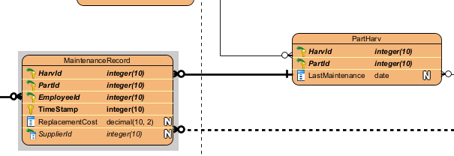

Another change to the relations designed in the previous step is the addition of the nullable column ‘decomissionDate’ to the Harv relation. This represents the date that the HARV was taken out of commission if applicable and is required for transactions that return the start and end date of a HARVs lifetime.

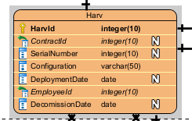

The other relations from the logical model will be translated without any changes to the physical model.

12.1.2. Constraints

Constraints described in the attributes table in the Logical design stage will be identified as well as other business constraints described within the project brief that couldn't be represented in the logical stage. These constraints are as follows:

- A gold or standard contract may be discounted by up to 3%

This constraint will be implemented through a check constraint on the Contract table ensuring that the DiscountPercent column is less than or equal to 3.00.

- A standard contract is negotiated by a salesperson
- A gold contract is negotiated by a salesperson
- A platinum contract is negotiated by an administrative executive
- A super platinum contract is negotiated by an administrative executive

These constraints will be implemented through foreign key constraints on the relevant table. The gold and standard contract’s EmployeeId foreign keys will reference the Salesperson table and the platinum and SuperPlatinum table’s EmployeeId foreign keys will reference the AdminExecutive table.

- A standard contract has exactly one HARV
- A standard contract has exactly one zone
- The zone of a standard contract may be no larger than 10.00 hectares
- A gold contract has exactly three HARVs
- A gold contract covers up to three zones
- The total area of the zones covered by a gold contract must not exceed 100.00 hectares
- The HARVs assigned to a super platinum contract are assigned exclusively to that contract
- Contracts paid annually are discounted by 10%

These constraints will be implemented using triggers on inserts, updates, and deletes as they need to check other tables to ensure they are met. When a constraint is broken by a transaction that transaction will be rolled back and a relevant error code and message will be returned.

12.2. Transaction Analysis

The diagrams use crows foot notation and include estimates for amounts of records within each entity. Any one-to-many or many-to-many relationships include an average and maximum amount of related records. The transactions were split into two diagrams to improve readability.

12.2.1. Transaction Diagrams

12.2.1.1. - D

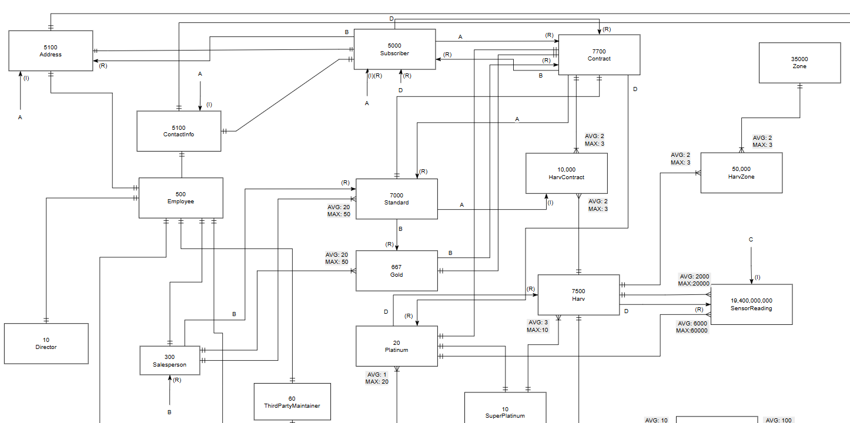

12.2.1.2. - J

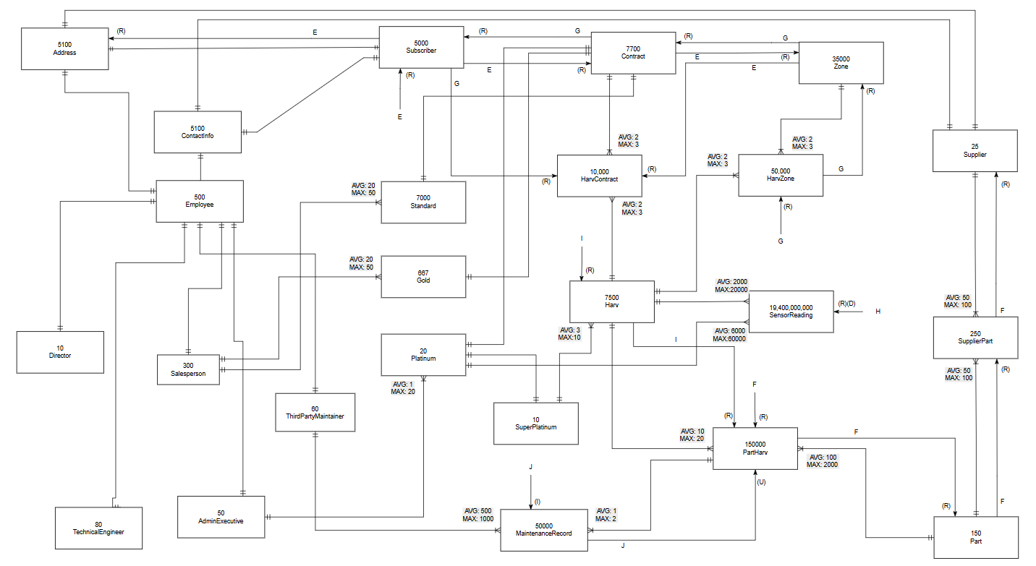

12.2.2. Transaction A
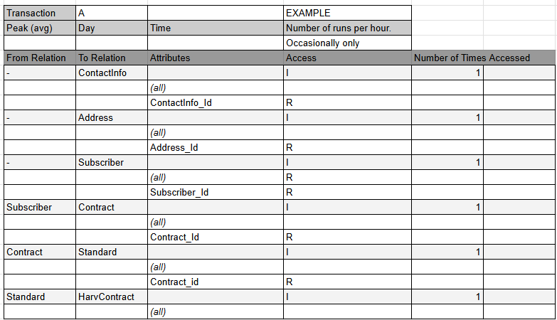

12.2.3. Transaction B
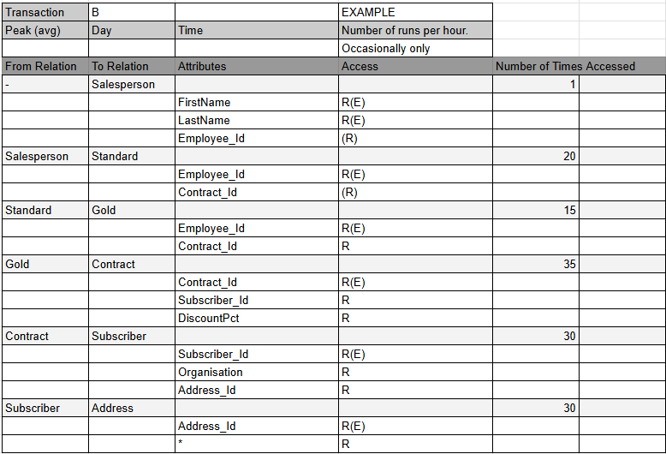

12.2.4. Transaction C
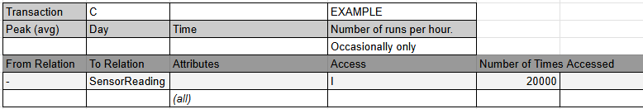

12.2.5. Transaction D
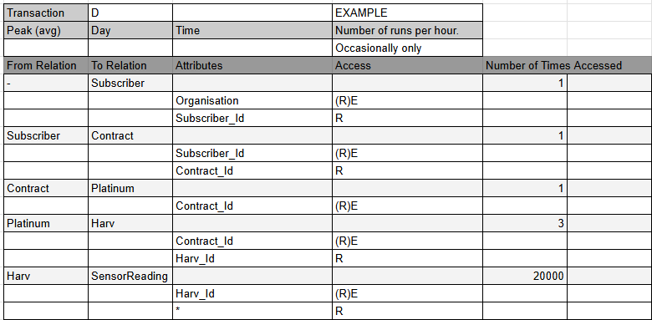

12.2.6. Transaction E
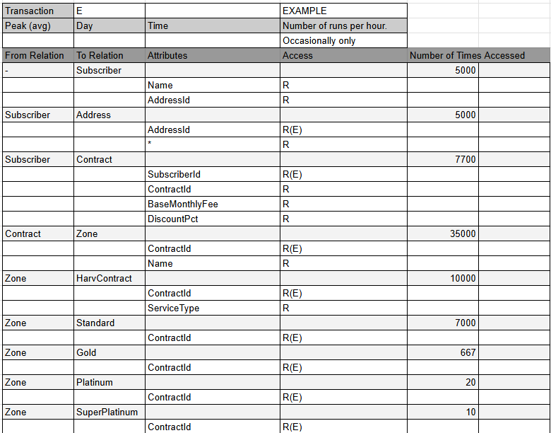

12.2.7. Transaction F
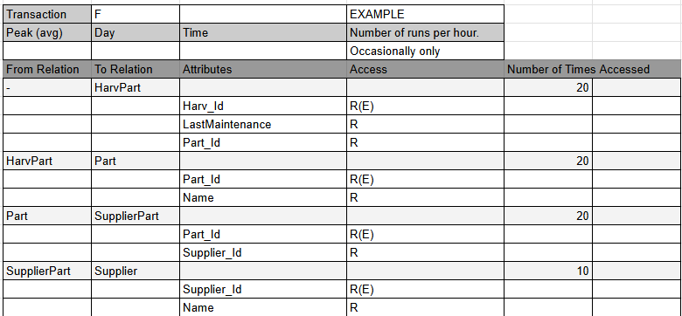

12.2.8. Transaction G
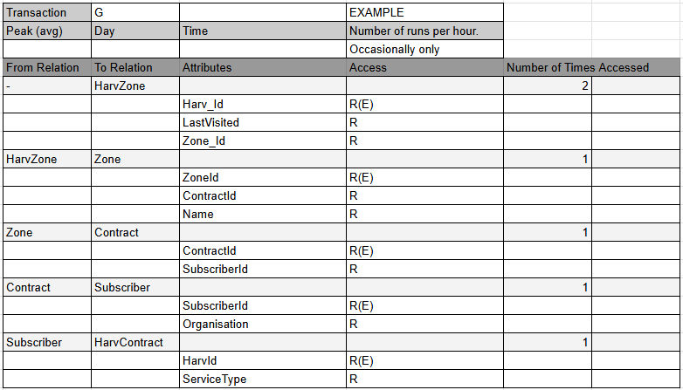

12.2.9. Transaction H
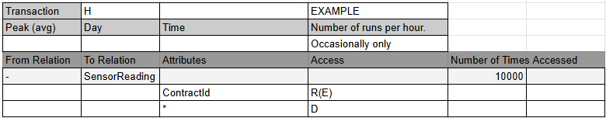

12.2.10. Transaction I
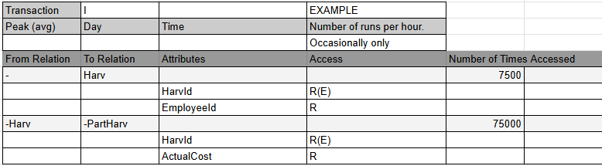

12.2.11. Transaction J
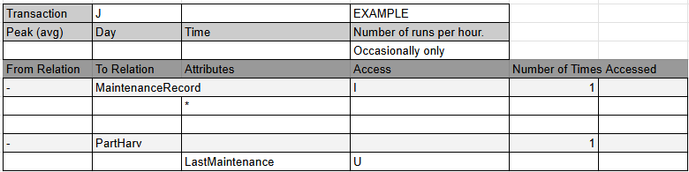

12.3. File Organisation

The file organisation for this database is B+-tree. SQL server uses B-tree indexes for all clustered and non clustered indexes within the database by default. This means that every table that has a primary key column gets a clustered index created on that key, which physically orders the data stored on disk by the values in that column. For tables with composite primary keys the clustered index is built on the full composite key in the order that the columns are created within the create table statement.

12.4. Secondary Indexes

The physical database will have six secondary indexes created based on the required transactions from the project brief. Creating these indexes improves the efficiency of the transactions but can increase the execution time of UPDATE and INSERT statements on these tables.

The first secondary index is created on the ContractId column of the SensorReading table. This will improve the execution time of both transactions D and H. Both of these transactions retrieve rows from SensorReading based on the ContractId column, with transaction D retrieving data for a given Platinum contract and transaction H deleting all sensor reading data for a given contract. As ContractId is not part of the clustered index created automatically the transactions would have to read through the full table in order to select the correct rows. With the projected size of the SensorReading table this could take a very large amount of time. Adding the index will significantly reduce this time by removing the need for scanning the entire table.

The second index is also created on the SensorReading table. This index will be created on the HarvId column in order to support transaction C which inserts large amounts of rows for the data of a given HARV. Although the HarvId column is part of the clustered index of this table, a separate, non-clustered index will allow for more efficient checks for duplicate key violations. This will greatly reduce the time taken for the large volume inserts required, such as a month of stored sensor data for a HARV being inserted at one time, by eliminating the need for scanning unrelated partitions of the table.

The third secondary index is created on the MaintenanceRecord table on the HarvId and TimeStamp columns, with ReplacementCost as an included column. This index will support transaction I which calculates total costs of replacement parts over a given time period. The index will allow the transaction to directly find the required HarvId and filter rows by timestamp without accessing the full table as replacement cost is available as an included column on the index. This will eliminate the need for a full table scan every time this transaction is run, which is important as this is expected to be a frequently run query in day-to-day business operations.

The fourth secondary index is created on the HarvZone table on the LastVisited column. This index will support transaction G which returns zones that have not been serviced within the last five days. The query will filter HarvZone rows on LastVisited being either NULL, indicating it has not yet been visited, or older than five days from the current date. Without this index transaction G would have to scan each row in HarvZone which is predicted to hold over 35,000 rows. The index will significantly increase the efficiency of this query.

The fifth secondary index is created on the HarvContract table on the ContractId column. This index will support transactions E and G. Transaction E generates invoices by joining through HarvContract to find HARVs based on a given ContractId. Transaction G uses the ContractId column to find zones that a given HARV is contracted to. Although ContractId is part of the composite primary key of this table it is the second column and therefore not the leading key of the clustered index. Placing a secondary non clustered index on this column means that lookups using ContractId alone will not require a full scan of the joining table.

The last secondary index is created on the Contract table on the SubscriberId column. This index will support transaction E that generates invoices for every active subscription. SubscriberId is a foreign key in the contract table and not part of the primary key and therefore does not have a clustered index by default. This means that transaction E would have to scan the entire contract table to find the contracts belonging to each subscriber. The secondary index will increase the efficiency of this large transaction that is predicted to be used often in business operations.

12.5. Database Sizing

A database size estimate has been created using the start volume and growth values from the logical model. A bytes per record value was calculated for each table using the size of the data type for each of those table’s columns. Data type sizes were found at ‘sqlservertutorial.net’ and variable length data types were assumed to be at their maximum length (“SQL Server Data Types,” n.d.).

Table | Bytes per record | Estimated records | Total Bytes
Address | 201 | 5,100 | 1,025,100
ContactInfo | 101 | 5,100 | 515,100
Subscriber | 54 | 5,000 | 270,000
Employee | 112 | 500 | 56,000
Director | 54 | 10 | 540
Salesperson | 54 | 300 | 16,200
AdminExecutive | 8 | 50 | 400
TechnicalEngineer | 54 | 80 | 4,320
ThirdPartyMaintainer | 104 | 60 | 6,240
Contract | 79 | 7,700 | 608,300
Standard | 8 | 7,000 | 56,000
Gold | 8 | 667 | 5,336
Platinum | 8 | 20 | 160
SuperPlatinum | 8 | 10 | 80
Zone | 43 | 30,000 | 1,290,000
Harv | 74 | 7,500 | 555,000
HarvZone | 12 | 35,000 | 420,000
HarvContract | 62 | 10,000 | 620,000
Supplier | 54 | 25 | 1,350
Part | 58 | 150 | 8,700
SupplierPart | 12 | 250 | 3,000
PartHarv | 12 | 150,000 | 1,800,000
SensorReading | 99 | 19,440,000,000 | 1,924,560,000,000
MaintenanceRecord | 28 | 50,000 | 1,400,000
Total |  |  | 1,924,567,661,826

13. Database Build (DDL) & Test Data (DML)

13.1. The Build (DDL)

The database was built using SQL Server Manager 2022 within a single script. The script creates the database and then creates a procedure that creates all of the required tables with the correct data types as defined in part 2 of this report. Each table’s primary key or keys are defined within this procedure. A second procedure was then created that creates the foreign key constraints for each table. A third procedure was then created that adds all the check constraints defined in section 12. These procedures are then executed within the script and triggers to enforce the remaining constraints are added. The secondary indexes defined in section 12 are also included in the script.

13.2. Test Data Generation (DML)

Test data was generated and added to the database in the same script using INSERT statements. Foreign key checks were disabled before these inserts and reenabled afterwards to prevent any errors on insert. To do this the following default stored procedure was used

EXEC sp_MSforeachtable 'ALTER TABLE ? NOCHECK CONSTRAINT ALL';

And the following default stored procedure was used to re enable and verify all of the foreign key constraints:

EXEC sp_MSforeachtable 'ALTER TABLE ? WITH CHECK CHECK CONSTRAINT ALL';

The test data ensures that each table has at least 5 rows of data, the data is varied and realistic, and that keys reference the correct rows in other tables. The data was added with the intention of testing all the required transactions. This includes Platinum contract sensor readings for testing Transaction D, sensor readings that are linked to a specific platinum contract for deletion in Transaction H, maintenance records with dates within the last 10 years and valid replacement costs for Transaction I, and HarvZone entries with a variety of LastVisited dates for Transaction G. Gold contracts were given exactly three HARVs and three zones to comply with the business rules stated in the project brief.

14. Transaction Implementation (Stored Procedures)

14.1. Transaction Queries

14.1.1. Transaction A

Transaction A, NewStandardContract, allows a salesperson to add a new standard level contract to the database by entering a SalespersonId, a DiscountPct, subscriber details, and a HarvId. The transaction creates a contract entry, a standard subtype entry, a subscriber entry for the contract owner including Address and ContactInfo entries for the subscriber, and a HarvContract allocation for one HARV. The transaction is wrapped in a TRY CATCH statement so that in the case of any errors the transaction can be rolled back and no partial data is left in the database.

14.1.2. Transaction B

Transaction B, GetSalespersonSubscribers, returns a list of all the subscribers a given salesperson has sold a subscription to. The transaction takes a salesperson's full name as input and uses a subquery with UNION to find all contracts sold across both gold and standard tiers, then joins to Contract, Subscriber, and Address to retrieve each subscriber's name, address, and the discount percentage applied to their contract. The results are then filtered where the salesperson’s name is the one given as a parameter when executing the stored procedure. Although the brief states that this transaction takes a salesperson’s name, a more efficient implementation would be to take an EmployeeId as this would allow for cases where two salespeople share a name.

14.1.3. Transaction C

Transaction C, InsertSensorReading, inserts a single sensor reading record transmitted from a HARV into the database. The procedure receives the HARV ID, the timestamp of the reading as recorded by the HARV itself rather than the current system time, the associated contract ID, and all sensor values including location coordinates, altitude or depth, temperature, humidity or salinity, turbidity, organic spectral data, and ambient light strength. Sensor values are nullable as not every sensor will be active on every HARV configuration. The procedure will allow for a continuous data stream as is described in the project brief and would typically be called very frequently as readings arrive from the HARV. The transaction is wrapped in a TRY CATCH statement so that in the case of any errors the transaction can be rolled back and no partial data is left in the database.

14.1.4. Transaction D

Transaction D, GetPlatinumSensorData, is used to retrieve all the sensor readings that are linked to platinum contracts belonging to a given subscriber. The procedure takes an organisation's name and filters sensor readings to return only those with a ContractId column matching that of a contract held by the given subscriber. Because of the secondary index created on SensorReadings ContractId column, the transaction can find readings for the relevant contract without scanning the entire SensorReading table.

14.1.5. Transaction E

Transaction E, GenerateMonthlyInvoices, prints an invoice for every active contract in the database. The procedure first declares all the variables that will be used to fill out the invoice details and then uses a cursor to iterate over each contract, joining the required tables, subscriber, address, and each contract subtype. The contract subtype joins use a left join which gives a null value for subtypes that the contract isn’t found in, and a case statement to assign strings to each of the types that can then be used to print the contract type in the invoice. The cursor then goes through each row in the contract table and the joined tables and assigns the values into the declared variables. Set statements then calculate and assign the three derived variables used, GST inclusive, GST amount, and GST exclusive. A print statement then prints an invoice header and fills out the invoice using the variables assigned above. Within each iteration of the first cursor a second cursor iterates over each zone assigned to the contract, and the service types found in the contracts' HarvContract entries and these are printed at the bottom of the invoice. Each cursor uses a while statement that uses FETCH_STATUS to check if there is a valid next row for the cursor to iterate through and exits the loop if there isn't one. This transaction fulfills the business requirement of generating invoices for every active contract.

14.1.6. Transaction F

Transaction F, GetHarvPartSuppliers, takes a HarvId as a parameter and returns all the names, supplier names, and the last maintenance date of all the parts in that HARV. It takes a HarvId and finds each PartHarv entry for that ID, joins with SupplierPart to retrieve the supplier’s ID and then joins with Supplier to get the supplier's name. The inclusion of the LastMaintenance column in PartHarv simplifies this procedure and removes the need to look through each maintenance record for the part to find the most recent date. This procedure allows staff to easily check all the parts in a HARV.

14.1.7. Transaction G

Transaction G, GetUnservicedZones, takes a HarvId as a parameter and returns a list of zone names, the organisation that holds the contract for that zone, and the date the HARV last visited that zone for each zone that HARV is assigned to that have not been visited within the last five days. The procedure also returns zones assigned to that HARV that have not yet been visited, identified by a NULL value in the HarvZone table’s LastVisited column. The secondary index that was created on the LastVisited column makes this procedure more efficient as it ensures a full table scan on HarvZone is not required. This procedure was created according to the project brief but a suggestion for improvement would be to take an amount of days as a second parameter to make the procedure more flexible.

14.1.8. Transaction H

Transaction H, DeleteContractSensorData, takes a ContractId as a parameter and deletes all sensor data that has been collected for that contract. As the project brief states only Platinum contracts receive data for their zones the contract Id must be that of a platinum contract. Transaction H is wrapped in a TRY CATCH statement, printing a message on successful deletion and in the case of any errors throwing that error and rolling back the transaction to prevent any partial data loss. The secondary index created on SensorReading’s ContractId column makes this transaction much more efficient as SensorReading contains a huge amount of rows and this index eliminates the need for a full table scan.

14.1.9. Transaction I

Transaction I, GetHarvReplacementCosts, calculates the total cost of replacement parts over the last 10 years for every HARV, as well as the name of the engineer that built the HARV and the date the HARV was deployed and decommissioned if applicable. The procedure joins each Harv entry to TechnicalEngineer and then Employee to get the engineer's name and then to MaintenanceRecord to get the replacement date and cost of each part. The transaction could optionally filter by HARVs that are yet to have a part replaced but the wording in the project brief states every HARV should be shown. Another potential improvement would be to take an amount of years as a parameter to check different time periods. Originally this procedure printed the start and end date of the period being checked but was changed to show the deployment and decommission dates.

14.1.10. Transaction J

Transaction J, LogScheduledMaintenance, logs a completed maintenance task by inserting a new MaintenanceRecord entry with all the maintenance task details. The way the database schema is designed, a scheduled maintenance task is for a single part on a single HARV. The transaction inserts the HarvId, PartId, the EmployeeId of the third party maintainer, and if a part was replaced, the SupplierId of the supplier that was used, as well as the date the maintenance was carried out. The replacement cost column is calculated using the current PurchaseCost of the particular part from the supplier that is entered in the transaction. The transaction also updates the LastMaintenance column for the part’s entry in PartHarv, this is important as it enables transaction F. Again the entire transaction is wrapped within a TRY CATCH statement so that if the insert or update fails the transaction is rolled back to prevent partial data entry.

15. Security Mechanisms

15.1. User roles
The database will have 5 different user roles as described in the project brief, these represent the different employee types employed by Coast and Canopy.

- Director
- Administrative Executive
- Salesperson
- Technical Engineer
- Third Party Maintainers

Each role will be assigned system permissions and access rules based upon the tasks that are required of them within the company. These roles are created within the SQL script and permissions are granted to each role rather than to individual users. This is the principle of least privilege where each role is granted only the permissions that are necessary to them. Roles are not mutually exclusive and users can be assigned multiple roles. For example an admin executive would typically also be assigned the salesperson role to get access to their permissions.

15.2. Access Rules

Access rules are also granted within the SQL script using GRANT statements. These access rules would be subject to change when other employee types and tasks not mentioned in the project brief are considered.

15.2.1. Director

Director is granted select and update permissions on the Contract table in order to change both monthly and annual base subscription fees in the BaseMonthlyFee and PayFrequency columns.

15.2.2. Administrative Executive

The administrative executive is granted select, insert, and update permissions on Contract, Platinum, and SuperPlatinum, as this is the employee type that can negotiate these contract types. They are also granted selection on the Subscriber, Zone, and Harv tables in order to retrieve information needed for their negotiations.

15.2.3. Salesperson

The salesperson is granted select and insert on Standard, Gold, Contract, Subscriber, Address, and ContactInfo, allowing them to create new Standard and Gold contracts and to register new subscribers. They are not granted update or delete on any table, preventing them from modifying existing contracts or subscriber details. select on Harv is granted so they can identify available HARVs to assign to new contracts.

15.2.4. Technical Engineer

The technical engineer is granted select on Harv, Part, PartHarv, and MaintenanceRecord. This gives engineers access to the HARVs they are responsible for building and the maintenance records of those HARVs while also not allowing any modifications to the database.

15.2.5. Third Party Maintainer

The third party maintainer is granted select, insert, and update on MaintenanceRecord and PartHarv. This allows them to enter maintenance records and update the date a part was last maintained. They are also granted select on Part, Supplier, and Harv so they can look up parts and suppliers. Finally they are granted insert on SupplierPart so that they can record new supplier and part relationships and the cost of parts from those suppliers as described in the project brief.

16. Final Reflection - Principles of Data Management

Principles of data management applied to the process are based on those described in the GARP published by ARMA international (ARMA International, 2009).

16.2. Principles of Data Management

16.2.1. Principle of Accountability

The principle of accountability states that an organization shall assign a senior executive to appropriate individuals, adopt policies and processes to guide staff, and ensure program auditability ((1) 8 Key Principles of Data Management | LinkedIn, n.d.).

16.2.2. Principle of Transparency

The principle of transparency states that an organization shall document its policies, processes and activities, including its data governance program, in a manner that is available to and understood by staff and appropriate interested parties.

16.2.3. Principle of Integrity

The principle of integrity states that a data governance program shall be constructed so the records and information generated or managed by or for the organization have a reasonable and suitable guarantee of authenticity and reliability.

16.2.4. Principle of Protection

The principle of protection states that the data governance program shall be constructed to ensure a reasonable level of protection to data that is personal or that otherwise requires protection.

16.2.5. Principle of Compliance

The principle of compliance states that an information governance program shall be constructed to comply with applicable laws and other binding authorities, as well as the organization’s policies.

16.2.6. Principle of Availability

The principle of availability states that an organization shall maintain its information or data assets in a manner that ensures timely, efficient, and accurate retrieval of its information. It includes the development of robust backup/recovery plans, efficient disaster recovery and Service Level Agreements as well.

16.2.7. Principle of Retention

The principle of retention states that an organization shall retain its information or data assets for an appropriate time, taking into account all operational, legal, regulatory and fiscal requirements, and those of all relevant binding authorities.

16.2.8. Principle of Disposition

The principle of disposition states that an organization shall provide secure and appropriate disposition of information in accordance with its policies, applicable laws, regulations, and other binding authorities.

16.1. Tabulated Reflection

Fundamental Principle | Application in Conceptual Design | Application in Logical Design | Application in Physical Design
Accountability | Staff roles were modeled in the conceptual ERD, each having different relationships and attributes based on their role within the company | These roles and their relationships were applied using a subtype hierarchy and specific foreign key relationships between the different employee and contract subtypes | Database roles were created with permissions granted to each based upon their responsibilities
Transparency | The process of creating the conceptual model was well documented with rationale explaining key decisions | The process of creating the logical model was documented using the NaLER analysis, the data dictionary, and the description of the normalisation process | The physical implementation was also documented in this report and the SQL script contains understandable comments describing the process and decisions
Integrity | Business rules and assumptions were identified in the conceptual stage to ensure that the data reflects real business operations | Normalisation to fourth normal form in the logical design eliminated redundancy and removed the chance of duplicate or inconsistent data | Primary keys, foreign keys, check constraints and triggers enforce data integrity, as well as try catch blocks with rollbacks to prevent invalid data from being entered
Protection | Contact information for subscribers and employees was separated to allow for independent access controls | The role based design of employee subtypes allowed for role specific access controls | Database roles ensure different staff only have access to the operations required to perform their roles
Compliance | Business rules from the project brief were implemented to ensure that the model complies with both legal and operational business constraints | The logical model includes cardinality constraints that reflect the contractual rules described in the brief such as zone and HARV limits | Check constraints and triggers help to enforce business rules and ensure compliance with company policies
Availability | The conceptual model was designed so that all the data needed for business operations was accounted for | The logical model was designed so that all the required data can be retrieved through the use of joins without redundancy | Secondary indexes were created to ensure efficient transactions. Transactions were created as stored procedures to be reusable and accessible
Retention | The project brief states HARVs transmit sensor data continuously to the Coast and Canopy database, and that maintenance records must be kept for each HARV over time, indicating that long-term retention of both sensor and maintenance data is a core requirement | The SensorReading table was designed with a composite primary key on HarvId and TimeStamp to support time-based filtering and retention queries. he database sizing analysis accounts for the projected growth of SensorReading over time, showing awareness of the storage implications of continuous data retention | Transaction I retrieves maintenance records over a 10 year period which demonstrates the database's ability to provide long term data retention.
Disposition | Including time stamps as attributes for various entities allows for the removal of old data. The need to remove data at the termination of a contract was identified during conceptual modelling of the relationship between SensorReading and Contract | The SensorReading table's FK to Contract allows targeted deletion of data by ContractId which allows for control of data disposition | Transaction H provides secure disposition of sensor data for a given contract and the secondary index created on ContractId ensures this can be done efficiently without affecting unrelated records

17. References

(1) 8 Key Principles of Data Management | LinkedIn. (n.d.). Retrieved June 24, 2026, from https://www.linkedin.com/pulse/8-key-principles-data-management-muhammad-salahuddin/
Athuraliya, A. (2025, May 14). Easy Guide to Chen Notation for Entity-Relationship Diagrams. Creately. https://creately.com/guides/chen-notation-in-erd/
Conceptual, Logical and Physical Data Model. (n.d.). Retrieved March 11, 2026, from https://www.visual-paradigm.com/support/documents/vpuserguide/3563/3564/85378_conceptual,l.html
SQL Server Data Types. (n.d.). SQL Server Tutorial. Retrieved June 24, 2026, from https://www.sqlservertutorial.net/sql-server-basics/sql-server-data-types/
What Is Data Modeling? | IBM. (2021, September 29). https://www.ibm.com/think/topics/data-modeling
ARMA International. (2009). Generally accepted recordkeeping principles. ARMA International. https://www.arma.org

